Issues in the Evaluation of a Program to Promote Educational Achievements of Ethiopian-Israeli High School Students
Dalia Ben-Rabi, Viacheslav Konstantinov, Ruth Baruj, Miriam Cohen-Navot
Myers-JDC-Brookdale Institute, the Engelberg Center for Children and Youth
Abstract

The paper describes an attempt to estimate the impact of an Israeli school-based intervention to promote the achievements of immigrant high school students from Ethiopia. The attempt rested on administrative data sets and the matching of participating students with non-participants, based on individual and school characteristics, including previous achievements. The analysis revealed that the intervention had impacted on student achievements, and that the most significant impact was on students with the lowest previous achievements, and on advancing students from lower to medium levels of achievements. This paper illustrates issues concerning conducting evaluation in real-life conditions, such as choosing the right impact measures for analysis, building the comparison group (given non-randomized allocation of schools and students to the program), choosing the comparison variables, dealing with partial data and interpreting the results.

Background
Israel has been absorbing immigrants from Ethiopia since 1984, though mostly in the 1990s. Ethiopian immigrants to Israel have had to deal with unique difficulties. Most of them came with little or no formal education and thus have only a limited acquaintance with the educational system and job market of modern Israeli society. The large gap between Ethiopian and Israeli culture presents challenges in all areas of life. This has also led to significant difficulties in learning Hebrew.
In addition, Ethiopian families are very large, and among them there is a much higher rate of one-parent families than in the general Israeli population. All of these factors have led to a very high rate of poverty among Ethiopian families and despite special government housing assistance, they reside for the most part in low-income and peripheral communities, which also limits their employment opportunities. As was mentioned before, many of the adults in these families came to Israel with very little formal education and were illiterate in their mother tongue; therefore, their ability to create a literacy-rich home environment, which may be one of the best predictors of a child's success at school (Jordan et al., 2000; Jacobs, 2004), and to be involved in their children's learning, is limited. As in other countries, these circumstances are reflected in a child's scholastic performance (Jacob and Ludwig, 2011).
Given these factors, it is clear that extensive assistance is required by Ethiopian-Israelis to enable them to fully integrate into Israeli society. Since the first wave of immigration from Ethiopia in 1984, many efforts and initiatives have been undertaken by the government, local authorities and voluntary organizations to support the Ethiopian population in integrating into Israeli society. However, significant gaps still remain in many areas (Wolde 2006).
The situation of the youth in the Ethiopian-Israeli community requires special attention. At the time of writing (2012), about 120,000 immigrants from Ethiopia (including their Israeli-born children) live in Israel; about half of them are under the age of 18. Due to immigration trends, the percentage of Israeli-born children is growing. For example, the percentage of Israeli-born in the Ethiopian-Israeli 17-year-old cohort grew rapidly between 2006 and 2008 – from 24% to 60%.
The importance of education and its significant impact on the future integration of Ethiopian-Israeli youth into Israeli society is well recognized. Israeli national data indicate that there are significant gaps in the educational outcomes of Ethiopian-Israeli youth relative to the general population. The achievement gap, apparent even 10 or 20 years after the families came to Israel, is seen from the lowest grades of elementary school through the end of high school. In 2002, the school dropout rate among Ethiopian-Israeli 17-year-olds was 12.8% compared with 7.3% in the general Hebrew-speaking population. In Israel, a matriculation certificate (high school graduation diploma, based on national exams) is a key measure of scholastic success and a prerequisite for admission to institutions of higher education. In 2002, the rates of eligibility for matriculation were 35.9% and 52.8%, respectively.
Research has shown the benefit of early-childhood programs in promoting the scholastic abilities and performance of children from disadvantaged backgrounds, though gaps remain between them and other children (Karoly et al., 2005). Some program benefits tend to fade over the years (Barnett, 2011; Nores & Barnett, 2010; Leak et al., 2010; U.S. Department of Health and Human Services, 2010; Reynolds et al., 2010). Moreover, scholastic demands grow with the transition from elementary to middle and high school and the children need ongoing support to keep up with the demands (Lee & Loeb, 1995).
The Ethiopian National Project (ENP) was first implemented in 2006, with the goal of helping youth whose families had immigrated from Ethiopia to Israel to realize their potential and increase their chances of social mobility and future successful integration into the labor market. The project comprises a variety of interventions, the most significant being the Scholastic Assistance Program. Aimed at Ethiopian-Israeli students in middle schools and high schools, it places special emphasis on matriculation exams. Furthermore, it strives to adhere what is considered as "best practice" principles for supplementary educational programs, among them: instruction in small groups with opportunities for individual instruction; extended participation (preferably, throughout all the years of high school); a supportive relationship between staff and students; learning-support activities (e.g., learning-skills workshops); enrichment and empowerment activities; involvement of regular school staff in implementing the program; family involvement; collaboration with community services and recruitment of counselors from the students’ cultural background (Joseph et al., 2010; Raley, Grossman, and Walker, 2008; Sheldon and Hopkins, 2008; Weinstein et. al, 2008). According to these principles, all participants receive instruction in small groups for about four hours weekly, in different school subjects. High school students also receive intensive assistance before matriculation exams. In addition, all students participate in social activities and some receive personal coaching. The program has grown rapidly and at its peak in 2008 reached over 100 schools with some 6,700 students in grades 7-12 (over a third of all Ethiopian-Israeli students in these grades nationwide).
The program has been accompanied by in-depth evaluation since its inception. The evaluation addressed three main aspects:
- The implementation of the program
- Satisfaction of the school principals and the participating students with the program and their assessment of its contribution
- The impact of the program on the students’ scholastic achievements.
The evaluation has provided regular feedback to support ongoing program improvement through in-depth interviews and focus groups with classroom teachers and key staff involved in direct implementation, observations of program activities, structured telephone interviews with school principals and self-report questionnaires completed by participating students. This paper focuses on the attempt to estimate the program impact on student scholastic achievement.

Methods and Data Sources
Several measures were selected to represent the program impact, to allow analyses reflecting both lower and higher levels of progress:
- Eligibility for partial matriculation certificates (which enables admission to advanced professional courses)
- Eligibility for matriculation certificates (a prerequisite for many jobs and some colleges)
- Eligibility for matriculation certificates with a high-level of English (a prerequisite for universities).
Aspiring to cover as large a number of students as possible, the program was introduced into every school willing to accept it, except for boarding schools and schools for children with special needs. In other words, the schools were not chosen randomly. Program schools were, on average, "stronger" than non-program schools in terms of the students’ achievements prior to the program and socio-demographic characteristics. Joining the program was not compulsory for students and, moreover, those who received other forms of assistance (such as mainstreaming support for students with special needs attending regular schools) were not included. On average, about two thirds of the Ethiopian-Israeli students at program schools participated in it. As we can see from the raw data for 2010, the achievements of participating Ethiopian-Israeli students were much higher than of their non-participating Ethiopian-Israeli peers, and were almost as high as those of the total 12th grade student body in Hebrew-speaking schools (see Figures 1,2). This was especially true of girls.

Figure 1: Percentage of Boys and Girls with Matriculation Certificates among Program Participants, Ethiopian Israeli 12th Graders and 12th Graders in Hebrew-Speaking Schools in Israel (2010)
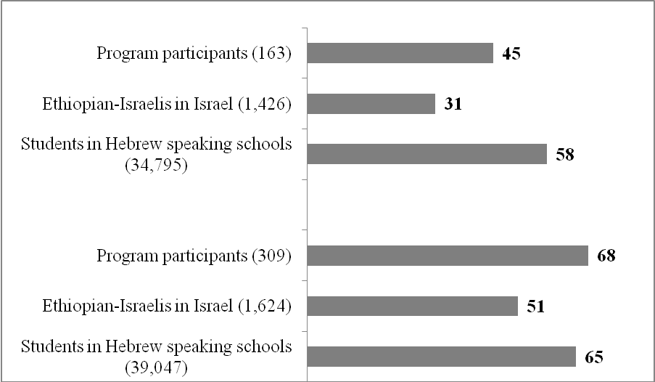
Girls
Boys
Figure 2: Percentage of Boys and Girls with Matriculation Certificates that Meet University Admission Requirements among Program Participants, Ethiopian-Israeli 12th Graders and 12th Graders in Hebrew-Speaking Schools in Israel (2010)
Boys

Girls

In the absence of a randomized control group, these data do not enable attribution of the difference in achievements to the program or estimation of its impact. When estimating causal effects using observational data, it is desirable to replicate a randomized experiment as closely as possible by obtaining treatment and control groups with similar covariate distributions. This can often be achieved by choosing well-matched samples of the original treatment and control groups, thereby reducing bias due to the covariates (Stuart, 2010). In this case, we created a comparison group retroactively, using data on students with similar characteristics from schools that did not participate in the program. Each participating student was matched to a non-participating student. The comparison enabled us to estimate what would have happened had the program not been implemented since the difference between the results for the two groups can be interpreted as the program impact. Note that the comparison schools, too, may have had various general scholastic assistance programs in which Ethiopian-Israeli students participated. In fact, a study mapping practices of Israeli schools to advance low achievers (Cohen-Navot et al., 2009) revealed that such supplementary programs were provided in about two-thirds of the country's middle schools. In addition, immigrant students (especially in the first years after immigration) are entitled to some assistance and special dispensations from the Ministry of Education. Our comparison, therefore, is of the added value of the program as opposed to whatever form of other assistance may exist in comparison schools. Two main analyses were conducted:
Analysis I: The comparison group was selected according to the students' socio-
demographic characteristics and the characteristics of the schools. The following variables were found to have a significant, stable impact on student achievement in various linear regression models:
- Student characteristics: country of birth (Israel/Ethiopia), gender
- School characteristics:
  - State or State Religious school
  - The percentage of students eligible for matriculation certificates among non-Ethiopian school students, in the year of the analysis
  - The percentage of students eligible for matriculation certificates among Ethiopian-Israeli school students in 2005, prior to the implementation of the program.
Analysis II: The comparison group was selected according to the variables listed for analysis I, and in addition, to the previous individual achievements of the students. The latter scores were taken from the 8th-grade national achievement exams (GEMS or meitzav) of the Ministry of Education (this measure was used instead of the percentage of Ethiopian-Israeli students eligible for matriculation in the schools prior to the implementation of the program, that was used in the first analysis). Since only about two-thirds of the students in program schools received assistance from the program, it could be argued that the program's achievements are due to its inclusion of the "strongest" students. This analysis aims, at least partially, to control for self-selection or for program-selection biases of inclusion based on student scholastic ability. At the same time, the analysis had some limitations. Firstly, GEMS data were available for only about half of the program students as the exams are annually administered to only a sample of schools. This could cause bias since there may have been different trends among schools who took the exams in a given year and schools who did not. Secondly, the GEMS scores represent previous achievement for only one year (8th grade) in four subjects (Hebrew language, English, math and science) and may not fully represent the students’ earlier scholastic ability in other area and in other years. Nevertheless, the average score of the four subjects was found to correlate highly with matriculation results both among the general student population and among Ethiopian-Israeli students.
To increase the number of students in the analyses and allow for more complex analyses and more stable estimates, combined analyses were conducted using data on program participants who took the matriculation exams in 2008-2010. The first analysis covered all 1,615 participating students and the second, 741 participating students, for whom GEMS data were available.
Two additional analyses were performed: one looked at the changing impact of the program over the years at schools participating for at least three years (28 schools). There, students that took the matriculation exams in 2008 had received program assistance for a year or two, whereas students that took the matriculation exams in 2010, had received program assistance for at least three years, and therefore the impact on the latter was expected to be greater. The other analysis examined the program impact on students with different achievement levels on the GEMS exams in 8th grade.
Several national data files of the Ministry of Education were used:
- Matriculation data on all Israeli students for the years 2005-2010 (the files include some demographic data)
- Data on student achievements on GEMS exams taken in 8th grade (a quarter of Israeli schools are annually administered these exams)
- Data on school characteristics.

Results
Estimated Program Impact, Taking into Account Previous Achievements of School
Impact on the Achievement of all Students Participating in the Program in 2008-2010
Taking into account student socio-demographic characteristics and school characteristics (including average achievements of the school's Ethiopian-Israeli students on matriculation exams, prior to the implementation of the program), significant impacts were found (see Figures 3,4):
- Eligibility for matriculation: The percentage of those eligible for matriculation was 55.2% among program participants vs. 44.2% of the comparison group. This can be interpreted as an improvement of 11 percentage points, or 25%, among program participants.
- Similarly, there was improvement on the other measures: passing the matriculation exams in math and Hebrew language, and the percentage of students achieving a partial matriculation certificate (improvements of 21 to 33%).
- There was a smaller improvement on the English exam (10%) and consequently a relatively small improvement in the percentage eligible for matriculation meeting university admission requirements (16%).

Figure 3: Matriculation Exam Achievements of Participating Students and Students in the Comparison group Based on Previous Achievements of School (2008-10), and the Impact of the Program (in Percentages) 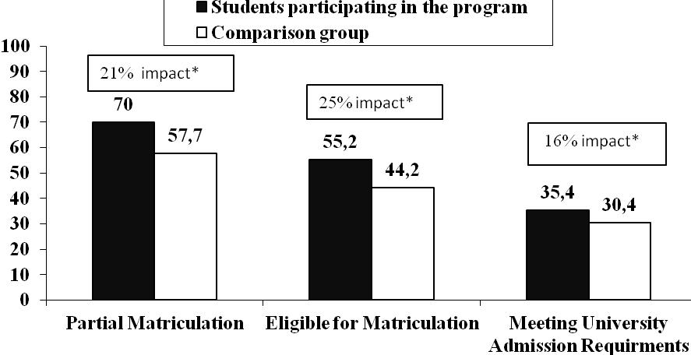
*p<0.01 n=1,615 program participants.

Figure 4: Matriculation Exam Achievements in Selected Subjects of Participating Students and Students in the Comparison group Based on Previous Achievements of School (2008-10), and the Impact of the Program (in Percentages) 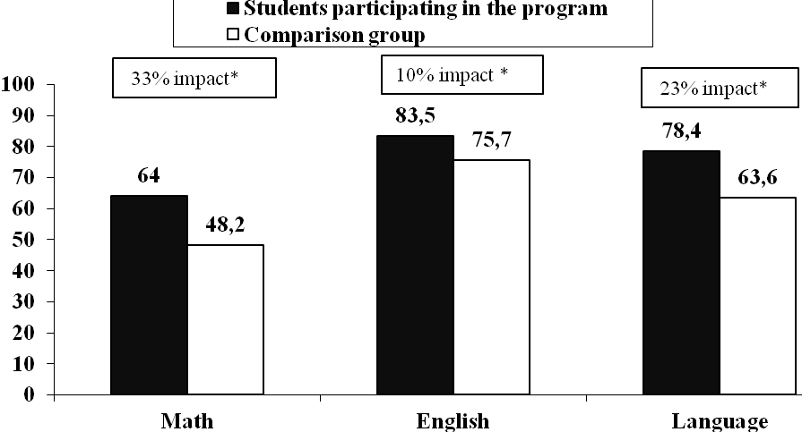
*p<0.01 n=1,615 participants

Changes in the Impact of the Program on the Same Schools, between 2007/8 – 2009/10
As the program grew, new schools joined each year. Most students who took the matriculation exams in 2008 had received program assistance for only one year (in the 12th grade). By 2010, most 12th graders in the program (approximately 85%) were attending schools participating in the program for the third year, and thus could be assumed to have received program assistance throughout grades 10 to 12. In the 28 schools participating in the program since 2008, we consistently found a significant increase over time in the program impact on the percentage of those eligible for both matriculation certificates and matriculation certificates meeting university admission requirements (see Figures 5,6).
Figure 5: Percentage Eligible for Matriculation Certificates among 12th Graders in the Program in 28 Schools Participating in the Program since 2008, and in the Comparison Group, by Year

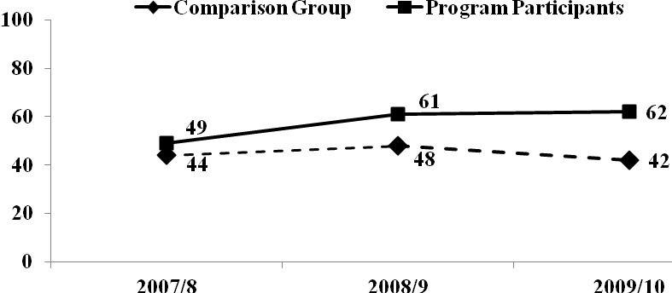
Not Significant

Impact*27%
Impact* 49%
*p<0.01

Figure 6: Percentage Eligible for Matriculation Certificates Meeting University Admission Requirements among 12th Graders in the Program in 28 Schools Participating in the Program since 2008, and in the Comparison Group, by Year

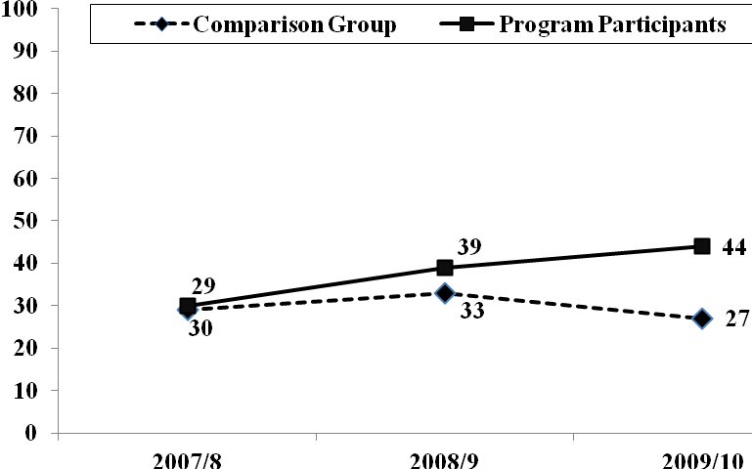
Not Significant

Impact* 20%
Impact** 63%
*p<0.05 **p<0.01

2008: 330 participants (74.3% of Ethiopian-Israeli 12th graders in these schools)
2009: 406 participants (74.2% of Ethiopian-Israeli 12th graders in these schools)
2010: 407 participants (69.6% of Ethiopian-Israeli 12th graders in these schools)

Changes in the Achievement Gap between Ethiopian-Israeli 12th Graders and Non-Ethiopian Students, in the Same Schools, between 2007/8 – 2009/10

Another measure of the program's impact is the changes in the achievement gap between Ethiopian-Israeli 12th Graders the non-Ethiopian students. This comparison can be used to separate the program's impact from that of other factors affecting the education system as a whole and these schools in particular, such as changes in the level of exams, national reforms or changes in school staff. We looked at the 28 schools which participated in the program for three years, and compared the achievements of program participants with those of non-Ethiopian students. In Figures 7, 8 we can see that while the achievements of the non-Ethiopian students have not changed over the years, there was a significant improvement in the achievements of the program participants, reducing the gap between the two groups:
- Percentage eligible for matriculation certificate: the gap declined from 20 to 7 percentage points – narrowing of 65% of the initial gap.
- Percentage eligible for matriculation certificate meeting university admission requirements: the gap declined from 31 to 16 percentage points – narrowing of 48% of the initial gap.

Figure 7: Percentage Eligible for Matriculation Certificate among Program Participants and Non-Ethiopian Twelfth Graders in 28 Schools that participated in the program since 2008, by Year

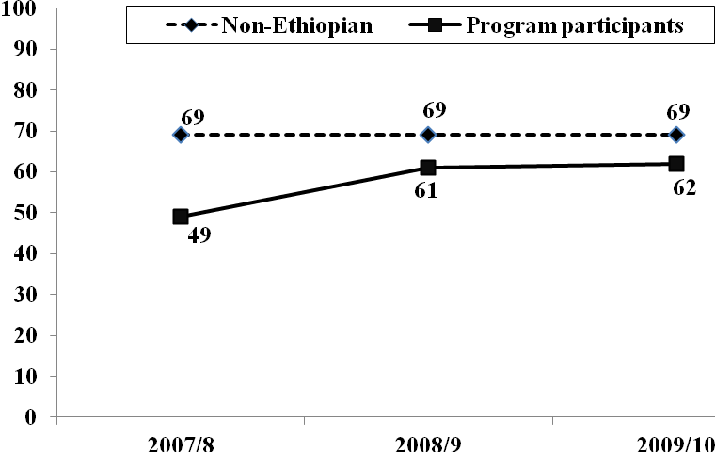

Figure 8: Percentage Eligible for Matriculation Certificates Meeting University Admission Requirements among Program Participants and Non-Ethiopian 12th Graders in 28 Schools Participating in the Program since 2008, by Year

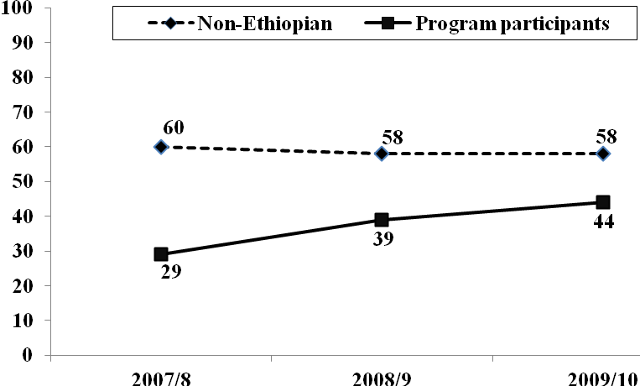
2008: 330 participants, 4,512 non-Ethiopian students
2009: 406 participants, 4,221 non-Ethiopian students
2010: 407 participants, 4,341 non-Ethiopian students

Estimated Impact of the Program, Taking into Account Previous Student Achievements

Impact on the Achievement of all Students who Participated in the Program in 2008-2010 for whom there were Data on Previous Achievement

The second analysis compares program participants and the comparison group using another variable – the students’ previous achievements, prior to participation in the program. As mentioned, the data required for this analysis were only available for about half of the students. Taking into account previous student achievements, the analysis still shows a significant (though smaller) program impact on student achievement in matriculation, on most measures (see Figures 9, 10).

Figure 9: Matriculation Exam Achievements of Participating Students and Students in the Comparison group Based on Previous Achievements of Student (2008-10), and the Impact of the Program (in Percentages)
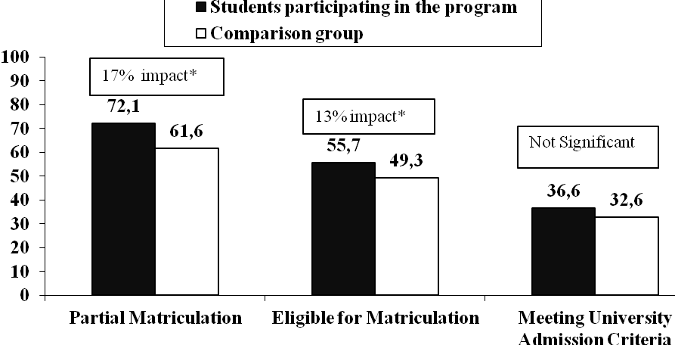
*p<0.01 n=741 participants

Figure 10: Matriculation Exam Achievements in Selected Subjects of Participating Students and Students in the Comparison group Based on Previous Achievements of Student (2008-10), and the Impact of the Program (in Percentages)
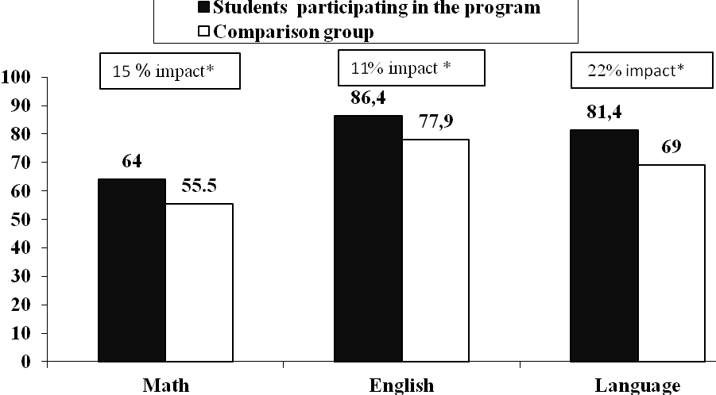
*p<0.01 n=741 participants

Impact on the Achievements of Students with the Lowest Previous Achievements
Scholastic assistance programs can have a differential impact on students with varying levels of scholastic ability. We divided the students into three groups, according to their achievements on the GEMS exams taken in 8th grade. Figures 11, 12 show the impact of the program on the weakest group, who had scored lower than 49 (on a scale of 0-100) on the GEMS. As expected, the matriculation achievements of these students were much lower than of the total program participants. However, the program impact (i.e., the difference, in percentages, between their achievements and those of a comparison group with similar earlier achievements) was greater than the average impact on the total participating group on most measures. Especially impressive is the impact on eligibility for a matriculation certificate meeting university admission requirements – only 6.5% of the comparison group achieved that, compared with over twice that – 13.5% – of program participants.
Figure 11: Matriculation Exam Achievements of Participating Students and Students in the Comparison group with the Lowest Previous Achievements (2008-10), and the Impact of the Program (in Percentages)

* p<0.05 ** p<0.01 n=282

Figure 12: Matriculation Exam Achievements in Selected Subjects of Participating Students and Students in the Comparison group with the Lowest Previous Achievements (2008-10), and the Impact of the Program (in Percentages)

* p<0.05** p<0.01 n=282
Discussion
This study aimed to estimate the impact of a comprehensive scholastic assistance program for Ethiopian-Israeli high school students, while trying to overcome the obstacles resulting from the lack of random assignment of schools and students to the program by creating a comparison group of matched students, based on administrative data.
The study showed a significant program impact on the matriculation results of participating students compared with non-participating students from similar schools, with similar socio-demographic characteristics, and with similar scholastic achievements several years earlier. The most significant impact was on students with the lowest previous achievements.
The impact of the program, reflected both in the improved achievement of Ethiopian-Israeli students (compared with non-participants) and in the narrowing of the gap between them and non-Ethiopian students, has increased as students have had the opportunity for more years of exposure. Nonetheless, considerable gaps still remain, especially as regards English exams. This poses a barrier to obtaining a matriculation certificate that meets university admission requirements.
The findings have served as the basis for discussions with program developers on a number of key issues:
- In view of the limited resources, does it make sense to invest in all the students or is it more cost-effective to focus on the weakest students who seem to benefit the most from the program?
- Do boys and girls require different forms of assistance?
- What additional assistance do the students need with English studies, which is often a third language for them (beyond Hebrew and Amharic, spoken at home)?
- How can the continuum between elementary school assistance and high-school assistance be strengthen?
- What are realistic expectations for attainable student achievements, given both the large gaps between them and other students – evident from kindergarten and growing over the years – and the scope of assistance that the program provides?

References
Barnett, W. S. Effectiveness of early educational intervention. Science 2011 Aug 19;333 (6045): 975-8.
Baruj-Kovarsky, R., Cohen-Navot, M. 2009. The Ethiopian National Project: Program for the Prevention of Alcohol and Drug Abuse 2008 -- Evaluation Study. Jerusalem: Myers-JDC-Brookdale Institute, RR-544-09 (English executive summary)
Cohen-Navot, M., Levi, D., Konstantinov, V., Awadyeh, I., Baruj-Kovarsky, R., Hasin, T. 2009. National study of primary and junior high school practices to advance low-achieving students: Final report. Jerusalem: Myers-JDC-Brookdale Institute, RR-509-09
Feliciano, C. 2012. The female educational advantage among adolescent children of immigrants. Youth & Society 44 (3) (September 01): 431-49.
Jacob, B.A., Ludwig, J. 2011. Educational interventions: Their effect on the achievement of poor children. In Neighborhood and life chances: How place matters in modern america., ed. Newburger, H., Birch, E.L., Wachter, S.M., 37-49. Philadelphia: University of Pennsylvania Press.
Jacobs, K. 2004. Parent and child together time. In Handbook of family literacy., ed. B. H. Wasik, 193-212 Mahwah, N.J.: Lawrence Erlbaum.
Jordan, G.E., Snow, C.E. & Porche, M. 2000. Project EASE: The effect of a family literacy project on kindergarten students’ early literacy skills. Reading Research Quarterly 35 (4): 524-46.
Joseph A. D., Roger P. W., and Pachan, M. 2010. A meta-analysis of after-school programs that seek to enhance the personal and social skills of children and adolescents. American Journal of Community Psychology 45 (3-4): 294-309.
Kahan-Strawczynski, P., Levi, D., Konstantinov, V. 2010. Immigrant Youth in Israel – the Current Situation. Jerusalem: Myers-JDC-Brookdale Institute, RR-561-10 (English executive summary)
Karoly, L. A., Kilburn, M. R., & Cannon, J. S. 2005. Early childhood interventions: Proven results, future promise. Santa Monica, California: RAND Corporation.
Leak, J., Magnuson, K., Schindler, H. 2010. Is timing everything? how early childhood education program impacts vary by starting age, program duration and time since the end of the program. Prepared for presentation at the Association for Policy Analysis and Management meetings, November 4-6, 2010 in Boston, MA.
Lee, V.E & Loeb, S. 1995. Where do head start attendees end up? One reason why preschool effects fade out. Educational Evaluation and Policy Analysis 17 (1): 62-82.
Nores, M., & Barnett, W. S. 2010. Benefits of early childhood interventions across the world: (under) investing in the very young. Economics of Education Review 29 (2): 271-82.
Raley, R., Grossman, J., & Walker, K. E. 2006. Getting it right: Strategies for after-school success. Philadelphia: Ventures Public/Private.
Reynolds, A. J., Magnuson, K. A., & Ou, S. R. 2010. Preschool-to-third grade programs and practices: A review of research. Children and Youth Services Review 32 : 1121-31.
Sheldon, J., & Hopkins, L. 2008. Supporting success: Why and how to improve quality in after-school programs. Public/Private Ventures.
Stuart, E. A. 2010. Matching methods for causal inference: A review and a look forward. Statistical Science 25 (1): 1-21.
U.S Department of Health and Human Services, a. f. 2010. Head start impact study. final report. Washington, DC.
Weinstein, M., Schwartz, A.E., Bel Hadj, A.H., and Stiefel, L. 2008. Closing the black-white achievement gap in high school: An assessment of evidence on interventions to improve test scores and college prospects of African American students. NYU Wagner Research Paper 2011-12.
Wolda, A. 2006. The Integration of Ethiopian Immigrants in Education and the Work: Summary of New Findings. Jerusalem: Myers-JDC-Brookdale Institute.

The study was funded in the support of The Ethiopian National Project.
Source: Myers-JDC-Brookdale Institute analyses of Israel Central Bureau of Statistics (CBS) population data.
Sources: Myers-JDC-Brookdale Institute special analyses of Ministry of Education and CBS data.
Better academic achievements among immigrant girls is also evident in other countries (see Feliciano, 2012)
Data show that on average, in all three years, the two groups of students (those who took the GEMS and those who did not) were quite similar in their socio-demographic characteristics.
For the analyses presented in this paper we used the average score of the four subjects.
The average scores on the GEMS (in different years) for students with matriculation certificates were statistically significantly higher (p<0.01) by 14-20 points (on a scale of 0-100) than the scores of students without matriculation certificates.
The difference between the groups (in percentage points) divided by the percent in the comparison group.
A similar picture is found when we look at the gaps between all Ethiopian-Israeli students in the 28 schools (both participants and non-participants) and non-Ethiopian students: between 2008 and 2010, the gaps were narrowed by 48% in eligibility for matriculation certificate, and by 37% in eligibility for matriculation certificate meeting university admission requirements.

