Teaching digital skills to “digital natives”? The role of teachers’ daily practises and attitudes towards new media

Gianluca Argentin, University of Milan-Bicocca
Marco Gui, University of Milan-Bicocca

tag words (max 3)
Digital literacy; ICT and education; teachers ICT use

Abstract
Using unique data surveying 3400 high-school students from two northern Italian regions (Lumbardy and Trentino), the paper examines the association between students’ perception of their teachers’ practises and attitude towards ICTs and the level of their digital skills. The results do not confirm the findings of a previous study by the authors (Argentin et al., in press) in that no significant association is found in the overall sample. However, analyzing the two regions separately a significant association is found in Trentino, but not in Lumbardy. In the conclusions, possible explanations of this differentiation are proposed.

Introduction

It is has been argued, both in academic literature and by international organizations, that digital literacy represents a key competence in the communication environment we live in. Especially in the fields of education and sociology, scholars have described digital skills as a new form of literacy (Warshauer, 2002; Buckingham, 2003; Eshet-Alkalai & Amichai-Hamburger, 2004, Van Dijk, 2005). The European Parliament (2006) has included digital literacy among the eight key competences for human capital development in Europe and agreed on the following definition: “Digital competence involves the confident and critical use of Information Society Technology (IST) for work, leisure and communication. It is underpinned by basic skills in ICT: the use of computers to retrieve, assess, store, produce, present and exchange information, and to communicate and participate in collaborative networks via the Internet.”. An increasing interest in digital skills in the field of education can also be seen in the new measure of “digital reading”, which since 2009 has been added to the traditional print reading, math and science measures of learning achievements in the OECD/PISA surveys.
Digital skills have been analyzed in their multidimensional nature, often distinguishing between a technical dimension - the ability to operate hardware and software tools -, an operational dimension - the ability to navigate and search for content in digital environments - and a critical one, related to the skills to evaluate and critically assess virtual content and relationships (Van Dijk, 2005; 2006; Gui & Argentin, 2011).
Social sciences have studied digital skills also as a new source of inequality. In the literature, initial worries related to a digital divide between Internet haves and have-nots have developed into the more complex notion of digital inequality (Di Maggio et al., 2004): as Internet penetration rates began to increase quickly after the year 2000, especially among youth, differences in the way the Internet is used began to draw a greater attention than simple access to it (Hargittai, 2002; Van Dijk, 2005). International literature about digital inequality have focused mainly on usage differences between different social groups: the different activities they carry out online (Bonfadelli, 2002; Livingstone & Helsper, 2007), the opportunities and risks young people face on the web (Livingston & Helsper, 2007, Livingstone et al. 2011), the adoption and use of different social networks (Hargittai&Litt, in press; Hargittai&Hsieh, 2010) and, especially, the different levels of digital literacy.
For their primary role in the access to culture in digital environments, digital skills can represent an important factor contributing to the deepening or reduction of social inequalities, especially among young people (Hargittai, 2002; DiMaggio et al., 2004; Sartori, 2006; Hargittai, 2008; Bentivegna, 2009). Empirical research have developed instruments to measure the level of digital skills in their different dimensions (Hargittai, 2002; Eshet-Alkali e Amichai-Hamburger, 2004, Gui, 2007), also with a specific focus on youth (Gui&Argentin, 2011; Calvani et al., 2011). Contrary to popular beliefs on the so-called digital natives discourse - arguing that people that have been born inside the digital world have a natural familiarity with these instruments (see Prensky, 2001) - research has found that young people show differences and deficits in the level of skills and awareness of Internet logic, according to age, education level, socio-economic status and gender (Livingstone e Helsper, 2007; Calvani et al, 2011; Gui &Argentin 2011, Van Deursen &Van Dijk, 2009). Therefore, on the one hand school should equalize existing differences and potential inequalities in the level of digital skills, and on the other it should face the lack of critical skills among young people, whose digital competence often remain confined to an operational dimension.
What educational policy makers and teachers miss the most are indications about how to better integrate ICT into teaching practices and, in particular, on the role teachers can have in the development of digital skills. In a previous research carried out by the authors (Argentin, Gui &Tamanini, in press), a statistically significant relationship between teachers’ practices concerning ICT and the level of digital competence of their students was found. The estimated robust correlation between a standardized index of teachers’ practices/ attitudes and their pupils’ standardized digital skill measure was about 0.25. Clearly we did not estimate an effect, but the strength of the observed association could make it “educationally significant” (Lipsey et al 2007). However, the previous sample presented limitations due to the limited total number of participants (n=980, 65 classes) and, more relevant, to its local nature, being based on a small province in the north eastern part of the country.
The aim of this study is to better investigate this topic and – thanks to a larger and less local sample - to test whether teachers’ digital practices in classrooms influence students’ digital skills. To do this, we use data coming from two surveys on random sample of high-school students in two important Northern Italian regions. Together with the surveys, an in-depth test to investigate the level of digital skills has been administered to the participants in both surveys. By looking at the associations between students’ perception of their teachers’ practices/attitudes and the level of digital skills measured by the test, we aim at providing evidence about the role played by teachers in the developed of their pupils’ digital skills.

Related literature

Many authors in the educational sciences have argued that, in a digital era, teachers should develop their ability to develop the information literacy of their students (Probert, 2009; Rockman, 2005; Curzon, 2004; Doyle, 1999). Also, we have strong empirical evidence of a lack of critical awareness and evaluation skills of digital content among young students (Calvani et al., 2011; Gui e Argentin, 2011; Van Deursen e van Dijk, 2009). However, in most countries, school curricula do not consider the need to develop media competence in their students (David, 2009).
Ladbrook e Prober (2011), in a research conducted in New Zealand, show that teachers themselves have contradictory attitudes towards the digital competence of their students. On the one hand they say their students have higher abilities than they have with digital tools; on the other hand, they believe students are in great need of a support in their use of online information. The research also shows that, anyway, most teachers do not carry out any specific activities to develop these skills in their pupils. Instead, a few existing experiences of formal teaching in this field have shown positive results (Walraven et al., 2008).
It is well known that the daily interaction students have with their teachers can have an effect on their learning outcomes in all disciplines, as measured by standardized tests (Wayne e Youngs, 2003; Nye et al., 2004: Hanushek e Rivkin, 2010). Therefore, it doesn’t seem implausible that informal daily practises carried out by teachers can be beneficial for the development of digital skills, especially in its critical dimension.
Considering the italian school system, recent research has confirmed that new media use is high among Italian teachers (Gui, 2010), but it has also shown that this use often regards a “backstage dimension”: writing text to be used in classrooms, navigating to look for useful information related to teaching, printing documents (Gui, 2010). Activities bringing new media use inside the classroom are much less frequent. Also, notwithstanding a good general attitude towards digital media, teachers are very skeptic when students’ use of the Internet for doing their homeworks is considered (ibidem). Finally, research in the Trentino (a Northern Italian region) area showed that age is not a variable discriminating between different levels of ICT integration into teaching practises (Gui, 2009), suggesting that the mere arrival of new teacher cohorts will be not sufficient for the development of new teaching models. On the other hand, research on the development of digital skills in italian classrooms shows that schools have an equalizing effect as the kind of school attendend has a strong impact on students’ level of digital skills, especially for those coming from low socio-economic backgrounds (Argentin, 2007).
It should be considered that in recent years huge investments have been made in Italy on ICT development, both providing schools with technology and developing teachers’ technical ability to use them. However, these policies mostly focus on technology integration and on the transformation of learning environments. Activities that explicitly target the need to develop critical skills in students towards new media are missing.
Before being able to suggest effective policies in this field, however, we need empirical evidence about the role that teachers, through their daily use of ICT in the classroom, their attitude towards their use, the dialogue that they are able to open with their students on these issues can have in the development of digital competence, especially in its more “critical” dimension.

2. Methods and data sources

Differently from our previous study carried out in Trentino (Argentin et al., in press), this analysis is based on data coming from a new survey, conducted in Trentino and Lumbardy. Therefore we can rely not only on a sample of 10th grade students in a small North Eastern province, but also on a representative sample of students of the same age in a large North Western region. To have an idea of the total populations of 10th grade students in the two regions, there are around 5.000 students in Trentino and around 100.000 in Lumbardy. Moreover, Lumbardy is a very different context compared to Trentino: it contains the metropolitan area of Milan, and many other middle-size cities while Trentino is for the most part an alpine area with only one small-size city.
The sample size of the present survey is also different from that of the previous study: the questionnaire was administered to about 3.439 students in 181 classes (63 in Trentino and 118 in Lumbardy) while in the old survey the total number of respondents 980. The Trentino and Lumbardy samples are representative of their 10th grade students population. Our random sample has geographic areas and and type of school track as strata. Response rates were extremely high: around 95% of the sampled classes have been tested. Due to the need to have representative data for Trentino we oversampled the students in this province (Trentino has 1112 cases, Lumbardy 2327). For this reason, the overall sample with both regions is weighted to avoid biases.
The questionnaire administered to our sample was made up of two parts: a standardized test measuring the level of “critical digital skills” and a questionnaire about teachers use of ICT in classrooms and their role in the development of digital skills. The test is an improved version of the tool used by Gui & Argentin (2011) and it is focused on the level of awareness and the actual skills in information evaluation practices (“critical digital skills”). The test has been validated and provided reliable measures of digital skills on a Rash scale.
Our measure of teacher practices and attitudes with ICT is based on an index derived from the questionnaire. The index synthesizes the answers given to the following nine items (Do your teachers…?):
- help to judge the reliability of information on the Internet;
- advise how to avoid viruses;
- talk about the risks in online social networks;
- help to set privacy limitations on your social network accounts;
- talk about useful websites for school-related issues;
- talk about useful websites for leisure ;
- talk about the existence of groups of people that collaborate on the Internet;
- use the Internet with you.
The answer modes were the following: “yes, more than one teacher”, “yes, but only one teacher”, “no”.
As is clear, our information is based on students’ reports about their teachers’ behaviour. To reduce the risk of students misreporting their teachers’ behaviour, we consider the answer given by the majority of students within each class. In the rare cases when this approach is not possible we consider the mean between the two more frequent answers. Anyway, we made sure that had we adopted different procedures to build this index (for example, the rough mean of students answers) our conclusions would not have changed. Finally, in the present survey, we also collected more contextual information than in the previous one. Hence, using this new dataset and the rich information provided, we are able to estimate the influence of teachers ICT practises on students’ digital skills, replicating the previous analysis on a larger sample of students and schools and considering a wider set of control variables. We are able to test our previous results in two ways: 1. by checking its robustness thanks to additional control variables; 2. By validating previous results in a different context.
The association is estimated through OLS regression models taking into account the data class clusterization. In all analyses we test the robustness of the association controlling for a bunch of students and school characteristics. We present the following four models:
- mod0 is a null model, estimating the correlation between students digital skills (dependent variable) and teachers practices/attitudes;
- mod1 controls for region and for the school track, a crucial variable in our previous analyses, capturing all the observable spurious components and making redundant all the additional control variables;
- mod2 controls also for socio-demographic variables: sex, immigrant condition, parental education and social class ;
- mod 3 controls for the following dimensions: available Internet connection tools (an index); domestic ICT equipment (an index); daily Internet/Personal Computer use (an index and one variable); parental perceived digital skills (two variables); students school performance (four variables); classroom ICT equipment/use (two variables); school ICT equipment (an index and two variables).
Despite the large amount of control variables, we obviously cannot estimate “effects” but only robust associations. However, this is a preliminary step for a proper estimation of a causal effect in social sciences (Goldthorpe, 2012). Considering the little information existing about the role of teachers in the development of digital skills, we think that our observational analysis can significantly improve the knowledge in this field.

3. Results and discussion
As we said in advance, previous results from the first survey (Argentin et al , in press) showed positive and statistically significant associations between teachers’s use of ICTs in the classroom and their students’ digital skills. In that previous study, the strength of the association between the standardized index of teachers ICT use and students standardized score of digital skills seemed relevant: the beta coefficient was 0.25, meaning that an increase of one standard deviation in teachers’ use of ICTs is associated to an increase of digital competence similar to the average difference between males and females or between students coming from low and high educated families. It was impossible to make a causal claim about the estimated association, but we were quite confident in interpreting it as an influence of teachers on their students’ digital skills because it did not change when controlling for a large number of school and students characteristics. Also, it did not change when different definitions and measures of ICT use by teachers were used.
With the data coming from the new survey, we replicated the analyses using the previously described four models. Results concerning the overall sample are displayed in the following figure.

Fig. 1 – Estimated association between teachers practices/attitudes and their pupils digital skills (OLS models, standardized beta coefficients)

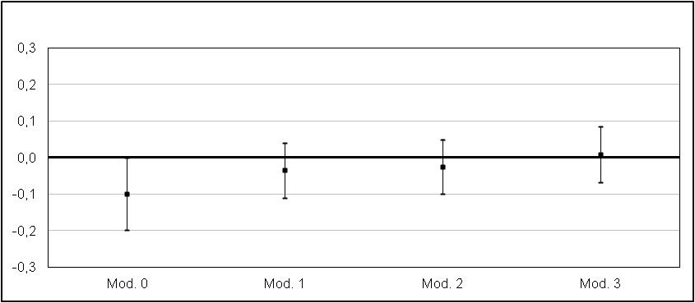

The new dataset does not confirm that teachers practices/attitudes play a role in developing students’ digital skills. We did not observe the previous positive association in none of the four models. This disconfirmation does not result from the use of additional control variables, considering that even model 1 (used in the previous study) shows a non significant association.
Considering that our sample contains students from two different contexts and that those from Lumbardy numerically overwhelm those from Trentino (the province where we found a positive association in our previous study), we decided to estimate the four models separately for the two regions. As figure 2 shows, we found a quite surprising result: Trentino confirms the positive association previously found, although with a smaller magnitude, while Lumbardy completely disconfirms it.

Fig. 2 – Estimated association between teachers practices/attitudes and their pupils digital skills by region (OLS models, standardized beta coefficients)

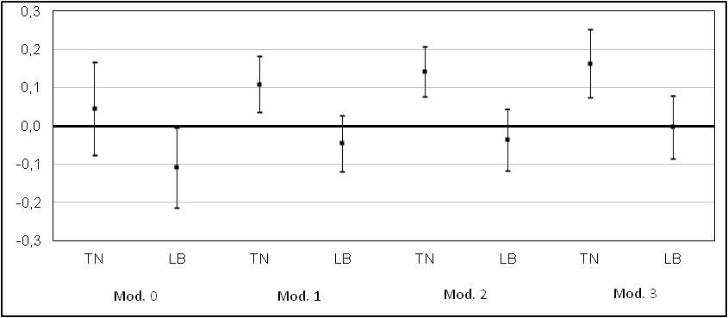

The result is even more surprising considering that the two variables considered (students digital skill measure and teachers practices/attitudes), are almost identically distributed in Trentino and Lumbardy.
Looking at these results we wondered whether the different strength of our association could be due to compositional effects: are teachers practices/attitudes differently effective on students subgroups and could be these differences the key explanation of the results? We tested the strength of the association by splitting the overall sample by any variables whose frequency is different in the two samples: immigrant status, parental education and school track. We did not find any evidence supporting the compositional effect hypothesis.
We then decided to statistically model the difference in the association between Lumbardy and Trentino through an interaction term in regression and we tried to mediate this term using control variables.
We formulated five plausible hypothesis potentially able to explain the observed results. The higher effective of teachers in Trentino could be due to the following factors:
- More technologically equipped households in Lumbardy and the constant availability of ICT promote the development of digital skills outside schools in Lumbardy.
- Thanks to the larger spread of wireless connection students in Lumbardty could develop their digital skills more easily through practice.
- The (slightly) higher level of (perceived) parental digital skills in Lumbardy could promote intra-family development of digital competence.
- The richer ICT equipment in Trentino schools could generate a setting promoting the development of digital skills: for example, 56% of students in Trentino are in a class equipped with an Interactive Whiteboard versus 28% in Lumbardy.
As figure 3 shows, none of the previous explanations help us to understand the differences in the association that we found between Lumbardy and Trentino: none of the many variables related to our five explanations in the full model mediate the interaction term. We also run separate models considering all the available indicators of each hypothesis, but the interaction term did not change.

Fig. 3 – Estimated interaction between region and teachers practices/attitudes on their pupils digital skills (OLS models, standardized beta coefficients)

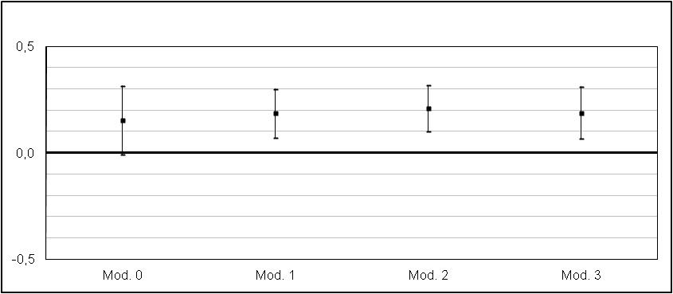

Another potential explanation lies in our general index of teachers practices/attitudes: it could not capture more qualitative differences between Trentino and Lumbardy teachers’ behaviour. Also the long term investment in teachers professional development on ICT occurred in Trentino could support this hypothesis. To test this explanation we compared the answers of students coming from Trentino and Lumbardy about their teachers item by item, but we did not observe any relevant differences.

4. Concluding remarks and further steps

Through these new analyses we were looking for a confirmation of previous promising results about the influence of teachers practices/attitudes on students digital skills. Our validation strategy was based on two steps: confirming previous results on a larger and less local sample; showing that they are robust also to a wider spectrum of control variables.
Results support the idea that the correlation previously observed in Trentino resist to further controls, but raise unanswered questions about the external validity of our results: in fact, in Lumbardy we found that there is no correlation between students’ skills and teachers behavior concerning ICTs.
We tested several hypothesis to explain the observed difference among contexts, but none has been empirically validated.
In the next months we will develop further analyses trying to identify subgroup of students/schools in Lumbardy showing a positive association between teacher practices/attitudes and student digital sills. By mean of this approach we will try to identify the characteristics able to make Trentino an effective context for teaching digital skills to digital natives.

5. References

Argentin, G. (2007), ICT, scuola e apprendimento: segnali di integrazione, in Cavalli e Argentin (a cura di), Giovani a scuola, Bologna, Il Mulino.

Argentin G., Gui M. e Tamanini C. (in press), Il ruolo degli insegnanti nello sviluppo delle competenze d’uso dei nuovi media, Scuola Democratica

Bentivegna, S. (2009) Disuguaglianze digitali. Le nuove forme di esclusione nella società dell’informazione.,Roma-Bari. Laterza.

Bonfadelli, H. (2002), The Internet and knowledge gaps: A theoretical and empirical investigation, European Journal of Communication 17(1): 65-84.

Buckingham, D. (2003). Media education: Literacy, learning and contemporary culture. Cambridge: Polity Press.

Calvani A., Fini A., Ranieri M. Picci P. (2011) Are young generations in secondary school digitally competent? A study on Italian teenagers - Computers & Education - 58. 797-807

Curzon, S. (2004). Developing faculty-librarian partnerships in information literacy. In I. Rockman (Ed.), Integrating information literacy into the higher education curriculum: Practical models for transformation. San Francisco: Jossey Bass.

David, J. L . (2009), Teaching Media Literacy, Educational Leadership 66 (6), pp. 84-86.

DiMaggio, P., E. Hargittai, C. Celeste and S. Shafer (2004), From Unequal Access to Differentiated Use: A Literature Review and Agenda for Research on Digital Inequality, in K. Neckerman (ed.) Social Inequality, pp. 355-400. New York: Russell Sage Foundation.
Doyle, C. (1999). Information literacy in an information society. In K. Haycock (Ed.), Foundations for effective school library media programs. Englewood, CO: Libraries Unlimited.
Eshet-Alkalai, Y. and Y. Amichai-Hamburger (2004), Experiments in digital literacy, Cyberpsychology and Behavior 7 (4): 425-434.

European Parliament (2006), Recommendation of the European Parliament and of the Council of 18 December 2006 on key competences for lifelong learning, http://eur-lex.europa.eu/LexUriServ/LexUriServ.do?uri=CELEX:32006H0962:EN:HTML

Goldthorpe, J. (2001),
http://esr.oxfordjournals.org/content/17/1/1.abstract

Gui M. (2009), L’uso dei media digitali nel lavoro degli insegnanti, in Bazzanella A. e Buzzi C., Insegnare in Trentino. Seconda indagine Istituto IARD e IPRASE sui docenti della scuola trentina, IPRASE, Trentino;

Gui M. (2010), L’uso didattico delle ICT, in Cavalli A. e Argentin G. (a cura di), Gli insegnanti italiani: come cambia il modo di fare scuola. Terza indagine dell'Istituto IARD sulle condizioni di vita e di lavoro nella scuola italiana, Il Mulino, Bologna.

Gui M. e Argentin G. (2011), The digital skills of Internet-natives. The role of ascriptive differences in the possession of different forms of digital literacy in a random sample of northern Italian high school students, New Media and Society, 13(6), 963-980.

Gui, M. (2007), Formal And Substantial Internet Information Skills: The Role of Sociodemographic Differences on the Possession of Different Components of Digital Literacy, First Monday 12(9)
Hanushek, E. A. e Rivkin, S. G. (2010), Using Value-Added Measures of Teacher Quality, in The American Economic Review, vol. 100 n. 2.
Hargittai, E. (2008). The Digital Reproduction of Inequality. In Social Stratification. Edited by David Grusky. Boulder, CO: Westview Press. 936-944.
Hargittai, E. & Hsieh, Y.P. (2010). Predictors and Consequences of Social Network Site Usage. Information, Communication & Society. 13(4):515-536.
Hargittai, E. & Litt, E. (In Press). The Tweet Smell of Celebrity Success: Explaining Twitter Adoption among a Diverse Group of Young Adults. New Media & Society.
Hargittai, E. (2002), Second-Level Digital Divide: Differences in People's Online Skills, First Monday 7(4)

Ladbrook, J. & Probert, E. (2011). Information skills and critical literacy: Where are our digikids
at with online searching and are their teachers helping? Australasian Journal of Educational
Technology, 27(1), 105-121. http://www.ascilite.org.au/ajet/ajet27/ladbrook.html

Lipsey M., Bloom H., Hill C., Rebeck Black A. (2007). How big is big enough? Achievement effect sizes in education. University of Pennsylvania Graduate School of Education.

Livingstone, S. and E. Helsper (2007), Gradations in digital inclusion: children, young people and the digital divide, New Media & Society 9(4): 671-696.

Livingstone, S., Haddon, L., Görzig, A., & Ólafsson, K. (2011), EU Kids Online final report, http://www2.lse.ac.uk/media@lse/research/EUKidsOnline/EU%20Kids%20II%20(2009-11)/EUKidsOnlineIIReports/Final%20report.pdf (pdf 52pp)
Nye, B., Kostantopoulos, S. e Hedges, L. V. (2004), How large are teacher effects?, in Educational Evaluation and Policy Analysis, vol. 26 n.3 pp. 237-257.
Prensky, M. (2001), Digital natives, digital immigrants, available at: www.marcprensky.com/Writing
Probert, E. (2009). Information literacy skills: Teacher understandings and practice. Computers & Education, 53, 24-33.
Rockman, I. (2005). Successful strategies for integrating information literacy into the curriculum. In I. Rockman (Ed.), Integrating information literacy into the higher education curriculum: Practical models for transformation. San Francisco: Jossey Bass.
Sartori, L. (2006), Il divario digitale, Bologna, Il Mulino.
Van Deursen, A. and J. Van Dijk (2009), Improving digital skills for the use of online public information and services, Government Information Quarterly (26), 333-340.
Van Dijk, J. (2005), The deepening divide. Inequality in the information society, London: Sage Publications.

Van Dijk, J. (2006), Digital divide research, achievements and shortcomings, Poetics 34 (4-5): 221-35.

Walraven A., Brand-Gruwel S., Boshuizen H.P.A. (2008), Information-problem solving: A review of problems students encounter and instructional solutions, Computers in Human Behavior, 24 (2008), pp. 623–648
Warschauer M. (2002), Reconceptualizing the Digital Divide. First Monday. Peer reviewed Journal on the Internet, 7, (7).
Wayne, A. J. e Youngs, P. (2003), Teacher Characteristics and Student Achievement Gains, in Review of Educational Research, vol. 73 n.1 pp. 89-122 .

tag words (max 3)
Digital literacy; ICT and education; teachers ICT use

See the activities carried out by the Ministry of Education to promote Digital Publishing of school-related content, the presence of interactive whiteboards (IWB) in the classroom and the project “Classi 2.0”.
See www.istruzione.it/web/istruzione/piano_scuola_digitale e www.scuola-digitale.it/.
We tested also the two gender subgroups.
See the project “E-Society” http://www.giunta.provincia.tn.it/binary/pat_giunta_09/XIII_legislatura/relazione_finale_task_force_interoperabilita_os.1134128198.pdf

