PARENTAL EMPOWERMENT IN MEXICO: RANDOMIZED EXPERIMENT OF THE “APOYOS A LA GESTION ESCOLAR (AGE)” IN RURAL PRIMARY SCHOOLS IN MEXICO

PRELIMINARY DRAFT: August 2012

Paul Gertler
Harry Anthony Patrinos+
Eduardo Rodríguez-Oreggia*

Abstract: Mexico has a limited version of School Based Management (SBM), but at the same time tries to follow the trend to improve school quality in rural poor areas. In this paper we evaluate the Apoyos a la Gestion Escolar, using double resources for a program directed to parents association, so they can work together with other agents in order to elaborate a work plan and use such resources for school improvements. We use a randomized experiment in 250 schools in rural areas of Mexico and measure changes during three years in outcomes such as repetition, failure and standardized test scores. Our main outcome measures are standardized test scores in math and Spanish in grades two to six. We find overall improvements in learning outcomes of more than 0.20 standard deviations in schools where the grant parent associations was increased. There are especially strong effects in standardized test scores for third grade students. Commitment and involvement of parents are relevant according to the teachers’ perspective. A separate component designed to test the impact of training parents, but no cash grant, in organizing themselves, proves successful as well, compared to a group of schools receiving neither grants, nor training. The effects of training alone are slightly higher than the cash grant, though the schools are not directly comparable.

JEL: I21, O31, C99
Keywords: randomized experiment, school based management, participation

^University of California, Berkeley
+ Lead Economist, World Bank
* Director of the PhD Program, EGAP Graduate School for Public Policy, Tecnológico de Monterrey, Campus State of Mexico. Email: eduardo.oreggia@gmail.com
Authors acknowledge research assistance from Angelica Rivera-Olvera and from Stefan Metzger in early stages.
1. Introduction
For development to take place, education should be addressed not only from the acquisition of levels but also from quality. According to the PISA international test scores, in 2009 Mexico performed 425 points in reading, and 419 in math, compared with 556 and 600 points of Shanghai-China, reflecting that policies for improving education outcomes are still to be more effective in closing differences. But also within Mexico there are wide differences between education performance between rural and urban schools, and between general and indigenous schools.

Besides the PISA results, standardized test in Mexico are of recent application. Mexico has implemented since 2006 the standardized tests ENLACE, which has been applied at the primary level from third to sixth levels, measuring the performance of students in math and Spanish, and an additional rotating subject. These tests are applied in all schools annually. There are however, deep differences between indigenous and general schools. For example, in 2006 the average score in Spanish was 500 points, while for indigenous was 420 points, and in 2010 the general score was 532 points, and for indigenous 453. In math also there is a lag: in 2006 the general was 500 while the indigenous was 429, and in 2010 the general was 530, and the indigenous 450. In general, for the four years that have been applied, the average for schools is to have marks for insufficient of about 20%, for indigenous the insufficient reach the 50% of students in both math and Spanish.

In rural Mexico, the poor suffer from inadequate service delivery, low levels of education, and poor infrastructure and housing conditions. Geographical location and isolation are powerful factors in explaining poverty and, by extension, economic and educational opportunities. Indigenous peoples constitute one of the most marginalized social groups in Mexico, a population historically excluded from the benefits of national development (Hall and Patrinos 2006). The majority of the indigenous population lives in small, rural communities – most of which are located in the poorer southern states. In terms of educational attainment, the indigenous population is catching up with, but still lags behind, the non-indigenous population. Ramirez (2006) shows that non-indigenous youth (age 7-14) have 8 percent more years of schooling than indigenous youth; however, the differential grows with age as indigenous children drop out of school earlier. Indigenous schools systematically score lower on standardized achievement tests, indicating a problem of low educational quality. In this context, equity and quality education are still significant challenges for Mexico.

What account for such differences, how spending could be improved, and what system should be better for increasing quality are clear subjects of analysis to study. In this sense, a stream of research has focused on how parental participation can improve education quality. The arguments for increasing parental participation in the school is that this will make teachers value children’s welfare more; that human, financial and material resources will flow to the school by virtue of parental support; and that more children will learn both at home and in the community that attending and doing well in school are highly valued.

Mexico is following the international trend of trying to improve educational outcomes in disadvantaged rural areas by decentralizing education decision-making through increased parental (and community) involvement in schools. The argument is that decentralizing decision-making authority to parents (and communities) fosters demand and ensures that schools provide the social and economic benefits that best reflect the priorities and values of their communities (Lewis 2006; Leithwood and Menzies 1998). However, many countries are moving forward with efforts to empower parents, often with little information of how the program worked in other countries. Moreover, there are high expectations, but little empirical research, with very few well- documented and evaluated cases. There is a need for more research that can lend empirical credibility to many of the claims (World Bank 2007a, b; Santibañez 2006).

In this regard, this paper presents the analysis from a randomized evaluation of the Apoyos a la Gestion Escolar (AGE), or Support to the School Management, a public program that provides the school with funds, of about $600, through the parents association, who have to outline a working plan in agreement with the principal, and teachers, and choosing in what to spend the money from a specific list provided by CONAFE. Even though this is a limited version of SBM, there is a dynamic of agreements to reach in each school that may spark the interest from parents in checking the quality of the education their children are receiving.

The strategy to use is a randomized experiment, where we selected 125 schools to receive the extra money for about $1,200, and 125 control schools that kept the normal amounts of about $600, for three years. Schools are located in rural areas in four southern states and with high indigenous people shares. We applied a series of baseline surveys in 2007 for the president of the parent association, principal, teachers, and students from third to fifth grades, and the consecutive follow up at the end of each school term until 2010. In addition we have data from the school census, and from the test scores. We are focusing on intermediate outcomes such as parental participation, teacher efforts, dropout, repetition, failure, and also on the improvement in test scores.

2. Literature review
Parental participation in school affairs can be seen as a moderate form of school-based management (SBM), which is the decentralization of authority to the school level (World Bank 2008a, b). Responsibility and decision-making over some aspects of school operations is transferred to parents, who must conform to, or operate within, a set of centrally determined policies (Caldwell 2005). SBM has become a very popular movement. A number of countries including New Zealand, the United States, the United Kingdom, El Salvador, Nicaragua, Guatemala, the Netherlands, Hong Kong (SAR), Thailand and Israel have instituted SBM. However, there is little empirical research with few rigorously evaluated cases – none of which is randomized (World Bank 2008a, b).

The empirical literature on SBM points to some impact on enrollment, dropout rates, parental involvement and student achievement. Parental involvement appears to increase, although the evidence is not overwhelming (Jimenez and Sawada 2003, 1999; Di Gropello 2006; Drury and Levin 1994). Teacher effort, measured by days worked or parent-teacher meetings, appears to increase in some cases, but not others (Di Gropello and Marshall 2005; Di Gropello 2006). El Salvador’s EDUCO (Educación con participación de la comunidad) program gives parent associations the responsibility for hiring, monitoring, and dismissing teachers. In addition, the parents are also trained in school management, as well as on how to help their children with school work. Despite rapid expansion of EDUCO schools, education quality was comparable to traditional schools. In fact, parental participation was considered the principal reason for EDUCO’s success (Jimenez and Sawada 1999, 2003). Nicaragua’s Autonomous School Program gives school-site councils – comprised of teachers, students and a voting majority of parents – authority to determine how school resources are allocated and to hire and fire principals, a privilege that few other school councils in Latin America enjoy. Two evaluations found that the number of decisions made at the school level contributed to better test scores (King and Ozler 1998; Ozler 2001). In a number of diverse countries such as Papua New Guinea, India and Nicaragua, parental participation in school management is associated with reduced teacher absenteeism (for a review see Patrinos and Kagia 2007; Karim et al. 2004).

The evidence on student achievement is mixed and in most cases studies estimating the impact on this measure use weak designs. However, the few studies that use stronger methodological strategies find either improved student achievement in elementary schools or very modest to no differences in test scores. For instance, Hess (1999) suggests that after initial slippage, student achievement is now increasing in Chicago public schools that implemented school-based management programs. He cites that 94 percent of elementary schools had higher percentages of students above the national norms in 1998 than they had at that level in 1990. The gains for the majority of elementary schools had been substantial (between 4-8 percentage points). Students enrolled in Honduras’ Community-Based Education Program (PROHECO) also appear to have higher test scores in science (Di Gropello and Marshall 2005). There is no statistically discernible PROHECO effect on math or language. For Nicaragua, King et al. (1999) found that having more autonomy over teacher-related issues does have a positive and significant effect on student achievement in primary and secondary schools.

Previous evaluations from Mexico are extremely limited, both in number and in robustness. Mexico’s urban school-based management program, PEC (Programa Escuelas de Calidad), was analyzed by Skoufias and Shapiro (2006) using panel data regression analysis and propensity score matching. They find that participation in PEC decreases dropout rates by 0.24 points, failure rates by 0.24 points and repetition rates by 0.31 points. Another evaluation of PEC finds the program did lower dropout rates, but not failure rates (Murnane et al. 2006). Neither study, however, analyzed student learning, because the timing did not allow for it, and because it was difficult to match student test scores (which were done on a sample basis), with the evaluation samples they used.

Shapiro and Moreno (2004) conducted an overall evaluation of Mexico’s compensatory program using propensity score matching. Mexico’s compensatory education program provides extra resources to primary schools that enroll disadvantaged students in highly disadvantaged rural communities. One of the most important components of the program is the school-based management intervention known as AGEs. They found that the intervention improved test scores. Lopez-Calva and Espinosa (2006), with data from 2003-04, and using matching techniques, found that the AGEs have a positive impact on test scores.

An evaluation of the AGEs using pre-program data over time and the phased-in introduction to construct an over-time difference-in-difference estimator, and controlling for fixed effects, shows a significant impact on reducing failure and repetition rates (Gertler et al. 2006). The impact of the AGEs is assessed on intermediate school quality indicators (failure, repetition and dropout), controlling for the presence of the conditional cash transfer program. Results prove that school-based management is an effective measure for improving outcomes. Estimates of the average treatment effect between school years 1998-99 and 2001-02 for failure, grade repetition and intra-year dropout rates, using school year 1997-98 as the pre-intervention year in the computation of the difference-in-difference treatment estimates, were calculated. Results consistently show a significant effect of AGEs in reducing failure and grade repetition, which is independent of the inclusion of controls for the other education interventions. The point estimates are -0.4 percentage points or, alternatively, a 4.4 percent decrease in the proportion of students failing or repeating a grade in the school. There are no effects of AGEs on intra-year dropout rates.

In an attempt to further justify the importance of the AGEs, qualitative work was undertaken, consisting of discussions with parents, teachers and school directors of beneficiary and non-beneficiary schools in the state of Campeche (for full details, see Patrinos 2006), and a larger survey of school directors in 115 rural schools with AGEs in the states of Campeche, Guerrero, Michoacán, Sinaloa and Tamaulipas (Gertler et al. 2006). In terms of economic and financial benefits, parents argued that AGEs monetary support helped to reduce the household burden associated with sending their children to school. They also argued that the AGEs helped improve school maintenance and that there are more school supplies. In addition, there were arguments that the AGEs help motivate the teacher. Another set of arguments from the parents focused on participation and other social aspects. Parents expressed the view that the AGEs helped generate significantly higher levels of school participation and communication – both amongst parents, and with teachers and school directors. The AGEs help articulate expectations and promote social participation. The AGEs meetings are important for the school as they facilitate dialogue with teachers and school directors. Many parents believe that the AGEs put pressure on school directors and teachers to help their children. Moreover, it is believed that the AGEs may help reduce absenteeism among teachers as they are seen as an economic benefit that helps teachers. The AGEs also motivate parents to follow their children’s progress. The school directors’ survey reconfirmed that the AGEs lead to improvements. According to the overwhelming majority of principals, the AGEs increase parental participation and make parents more demanding. However, they are more likely to demand higher teacher attendance and more attention to their children’s learning needs; not to change grades for undeserving students. Therefore, the qualitative results reconfirm our findings and contention that AGEs improve outcomes through increased parental participation, and probably through increased attention to teacher attendance and student’s academic performance.

Thus, while there is some evidence on the performance of SBM programs, little is known about their benefits in terms of learning outcomes in Mexico or elsewhere. Even fewer studies are based on rigorous impact evaluation techniques or investigate the mechanisms through which SBM might affect student performance. It is also not clear in cases such as the AGEs, where the parental participation is funded through school improvement grants, whether the observed positive effects are due to the extra resources (which in the case of the AGEs are used for small civil works) or the organization and empowerment of parents. In this respect, the current proposal will be relevant beyond Mexico. This piece of research will additionally yield unbiased estimates on the magnitude and direction of the effects of parental empowerment SBM programs on learning outcomes while further focusing on the factors and changes within the school that trigger such impacts. It will, therefore, provide invaluable insights and advice on ways of fine-tuning policies aimed at improving school quality, besides lending empirical credibility to many of the parental empowerment/SBM claims. We believe this is of particular importance now, given the increasing number of countries that are moving forward with efforts to implement empowerment/SBM-type education programs.

- AGE Program
Mexico’s compensatory education program began in the early 1990s. It is now implemented by the National Council for Educational Development (Consejo Nacional de Fomento Educativo, CONAFE), a division of the Mexican Secretariat of Public Education (Secretaría de Educación Pública, SEP). The School Based Management (SBM) component of the Compensatory Education Program – the Support to School Management (Apoyo a la Gestión Escolar) or AGE, started in 1996 and consists of monetary support and training (Capacitación a la Gestión Escolar, CAPAGES) to Parent Associations (Asociaciones de Padres de Familia), or APF. The APF can spend the money on the purpose of their choosing although spending is limited to small civil works and infrastructure improvements. Despite being a limited version of SBM, the AGE represents a significant advance in the Mexican education system, where parent associations have tended to play a minor role in school decision-making. AGE increases school autonomy through improved mechanisms for participation of directors, teachers, and parent associations in the management of the schools. The AGE financial support consists of quarterly transfers to APF school accounts, varying from $500 to $700 per year according to the size of the school. The use of funds is specified in the Operational Manual of the project and is subject to annual financial audits for a random sample of schools. Among other things, the parents are not allowed to spend money on wages and salaries for teachers. The intervention was complemented, starting in 2003, with a training component (CAPAGE) aimed at guiding parents in the management of the school funds transferred through the AGE. The CAPAGE also provide parents with participatory skills to increase their involvement in school’s activities and with information on achievement of students and ways in which parents can help improve their learning outcomes.

4. Design of the Experiment
The randomization was conducted in several steps together with CONAFE in the selection and randomization of the primary schools that were to compose the evaluation sample. Schools in the treatment group received the extra grants for three consecutive school years. Schools in the control group remain as counterfactual schools and therefore did not receive the extra benefits over the evaluation period. Both groups of schools were already incorporated into the AGEs and all received the base amount.

First, we selected states with large indigenous rural populations, and that were well represented in the AGEs program. Budget restrictions allow the awarding of only a certain number of extra grants for the experiment each year, limiting our sample to 250 AGEs schools, of which we can only allocate extra resources to half. A statistical power calculation indicates that a sample of this size is sufficient to detect moderate student learning impacts at 95% confidence with reasonable levels of statistical power.

Since 2000, almost 50,000 rural primary schools have benefited from AGEs. During school year 2006-07, there were 34,252 AGEs in 31 states. Our selected states, which have large indigenous populations as measured by their proportion in rural areas, are: Chiapas, Guerrero, Puebla and Yucatan. These four states account for 14 percent of the Mexican population overall, 22 percent of the rural population, and 37 percent of the national indigenous population. We excluded Oaxaca, even thought it has the largest indigenous population in a single state, because of problems between the teachers’ union and the government, which led to the closure of schools during most of the 2006-07 school year, and AGEs funds were not assigned. Similar problems exist to this day, and there were no guarantee that the experiment could be carried out in the state (see, for example, the daily Excelsior newspaper, 16 July 2007, “Regresa violencia a Oaxaca”). Furthermore, Oaxaca schools did not participate in ENLACE in 2006 and 2007, meaning that we do not have a baseline for the state. Our four selected states account for 17 percent of all primary public schools in Mexico, and almost 20 percent of all AGEs schools. In 2006-07, AGEs schools were distributed by state as follows: Chiapas (2,675), Guerrero (2,399), Puebla (1,265) and Yucatán (323).

We randomly selected 250 schools as participants of the experiment. This was carried out using the 2007-08 database of AGEs schools provided by CONAFE, as well the national school census by SEP, which contains numerous characteristics at the primary school level for the beginning and end of each school year (see Table 1).

Table 1: Primary Schools in Selected States
State | Total | of which indigenous: | AGEs Schools | of which indigenous: | Potential AGEs* | of which indigenous:*
Chiapas | 6,480 | 2,759 | 2,620 | 1,497 | 2,522 | 1,432
Guerrero | 4,030 | 850 | 2,437 | 721 | 2,086 | 573
Puebla | 4,256 | 604 | 1,173 | 350 | 995 | 200
Yucatan | 1,266 | 171 | 344 | 163 | 327 | 162
Total | 16,032 | 4,384 | 6,574 | 2,731 | 5,930 | 2,367
*Excluding boarding schools and those not participating in ENLACE tests in 2006

From the universe of AGEs schools in the four states we excluded boarding schools, schools that did not participate in ENLACE 2006, and schools that joined the mostly urban school-based management program (PEC). This left us with 5,930 potential schools to be selected for the experiment, of which 2,367 were indigenous. From these we randomly selected 250 schools. Table 2 presents the distribution of the randomized schools.

Table 2: Random Distribution of Schools
State | General | Indigenous | Total
Chiapas | 45 | 66 | 111
Guerrero | 58 | 22 | 80
Puebla | 28 | 15 | 43
Yucatan | 6 | 10 | 16
Total | 137 | 113 | 250

The randomization produced a distribution of indigenous and general schools that is close to the actual distribution of indigenous and general schools in the four states, as shown in Table 3. In other words, the randomly selected schools are representative of the distribution of indigenous and general schools in the four states. The 250 schools were within in the AGEs program for at least the three year duration of the experiment.

Table 3: Distribution of General and Indigenous Schools (percent)
 | Actual distribution |  | Sample distribution
State | General | Indigenous | General | Indigenous
Chiapas | 43 | 44 | 44 | 58
Guerrero | 35 | 33 | 33 | 19
Puebla | 16 | 17 | 17 | 14
Yucatan | 6 | 6 | 6 | 9
Total | 100 | 100 | 100 | 100

From these 250 schools, we randomly assigned 125 to treatment and 125 to control. Using then about a set of characteristics for the 2006 an previous two years in order to guarantee that such characteristics are constant over years, we calculated t-test to compare random selected treatment and control groups after 50 random runs until produced the more similar distribution for both groups according to the t-test difference. Variables included were: the number of students and groups per each grade; repeaters, ratio of approved per grade; number of teachers and principal with group and number of groups per grade; dropout rates, ratio of repeaters, scholarships Oportunidades, supplies per grade; teachers incentives and their ratios and the existence of other programs such as Carrera Magisterial, training, and also for the intensity of such programs. In general, of about 188 characteristics (per grade and for 3 years) 91% of them are similar according to the t-test.

Table 4 presents the final distribution of treatment and control schools according to whether they are indigenous or general schools.

Table 4: Treatment and Control Schools
 | Indigenous |  | General |  | Total
State | Treatment | Control | Treatment | Control | Treatment | Control
Chiapas | 38 | 28 | 22 | 23 | 60 | 51
Guerrero | 12 | 10 | 23 | 35 | 35 | 45
Puebla | 9 | 6 | 16 | 12 | 25 | 18
Yucatan | 4 | 6 | 1 | 5 | 5 | 11
Total | 63 | 50 | 62 | 75 | 125 | 125

- Empirical Strategy of the Evaluation

- Analysis for school level indicators
Since we have a randomized design of the sample, where ex ante the treatment and control were randomly assigned, we want to check whether the outcomes have changed due to the experiment. For the school level indicators we are using data from the 911 School Census. As noted previously, the randomization has guaranteed that treatment and control groups are similar in characteristics and t-tests carried out for using the baseline surveys confirm this.

We are implementing a Difference-in-Difference strategy in order to know how such outcomes have changed due to the double AGEs program, where the model is:

(1) Y_{jt}=α+βT_{j}+γD+δT_{j}*D+ε_{j}

where Y is the outcome of interest for school j in year t; T is a dummy for treatment schools, i.e., those that were randomly assigned to receive double AGE; D is a dummy for data in the follow-up years, i.e., post-treatment; and δ is the parameter of interest denoting the impact of the program on the outcomes.

In addition we are interested in calculating the specific effect of the program in those indigenous schools. In order to disentangle such effect, we implement a triple difference strategy with a model:

(2) Y_{jt}=α+βT_{j}+γ₁D+γ₂Ι_{j} +δ₁T_{j}*D+δ₂T_{j}*D *I_{j}+δ₃I*D+δ₄I*T_{j} +ε_{j}

Where i denotes if the school is catalogued as an indigenous school by the government, and δ₂ gives the specific impact on indigenous school due to the program.

We are also implementing a school level fixed effects strategy in order to check if still some unobserved could affect the findings. Standard errors are clustered at the state level, where many decisions are taken.

- Analysis at the individual level indicators

We have collected surveys for the principal, teachers, and president of the parent association, as well as students (for 3rd, 4th and 5th grades), in a baseline survey in 2007 and the follow up at the end of scholar years from 2008 to 2010. For principal, teachers and parents, there were questions regarding how often they meet with the other agents involved in writing the work plan for improvements, what factors are becoming relevant for designing such plan, and attitudes and commitments to collaboration and improvement for all of them.

We are following the same Difference-in-Difference strategy adapting equation (2) to be:

(3) Y_{it}=α+βT_{i}+γ₁D+γ₂Ι_{i} +δ₁T_{i}*D+δ₂T_{i}*D *I_{i}+δ₃I*D+δ₄I*T_{i} +ε_{i}

where Y is the outcome of interest and i is the individual interviewed.

In this case we are calculating the impact with different methods since the outcome has variations. In the case of the number of meetings, we have some ceros and limited number of meetings, therefore we will be using a negative binomial estimation. In the case of if all agents have participated in the design of the plan, and what factors are important for designing it, we are using a probit model. For those questions regarding implication of agents for improvements, and the attitudes for improvements, we have calculated an index using principal components for these Likert scale like questions, then using ordinary least squares with the panel data to calculate the impact of the AGEs.

5. Results
Intermediate Outcomes
Intermediate Outcomes – Training vs Pure Control

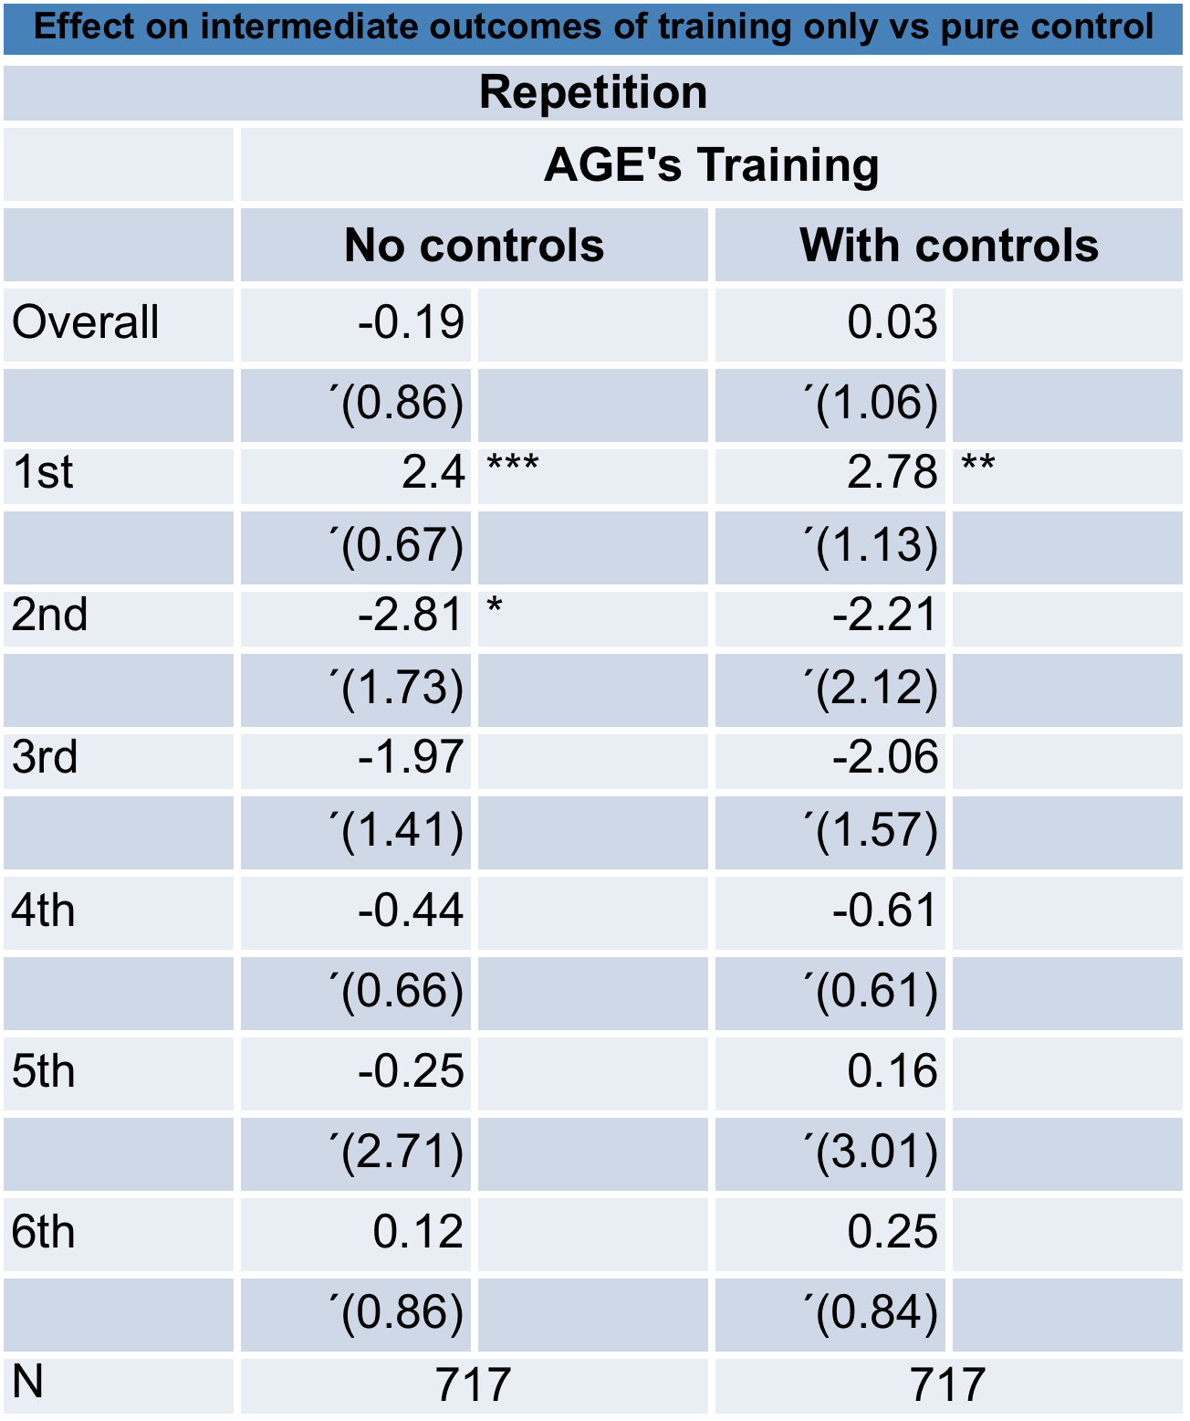
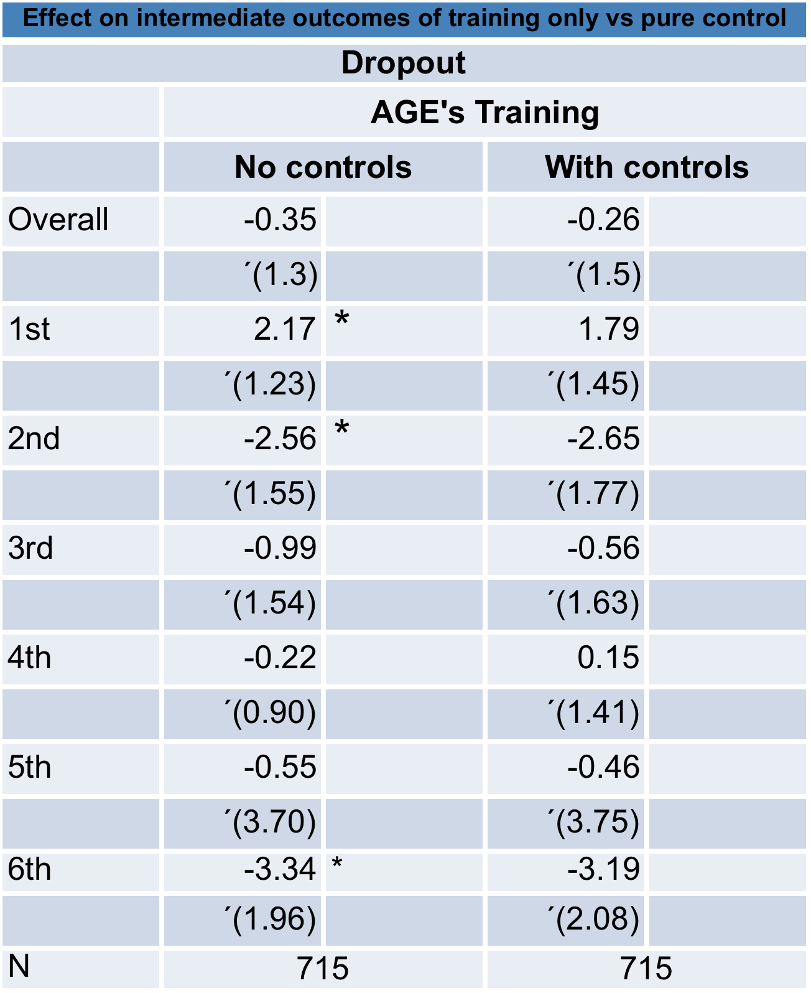

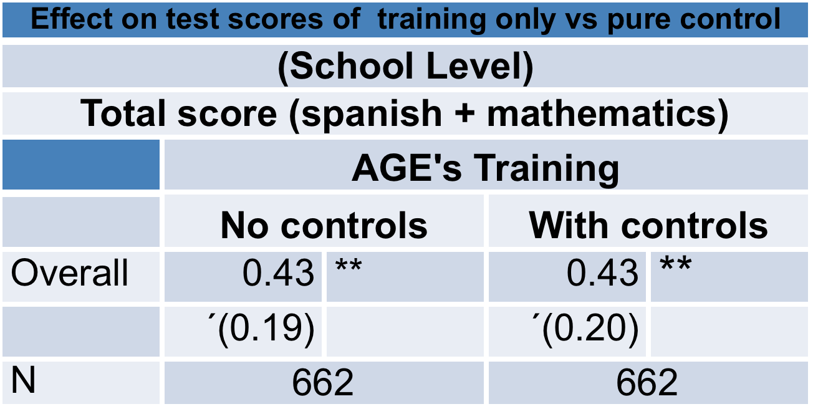
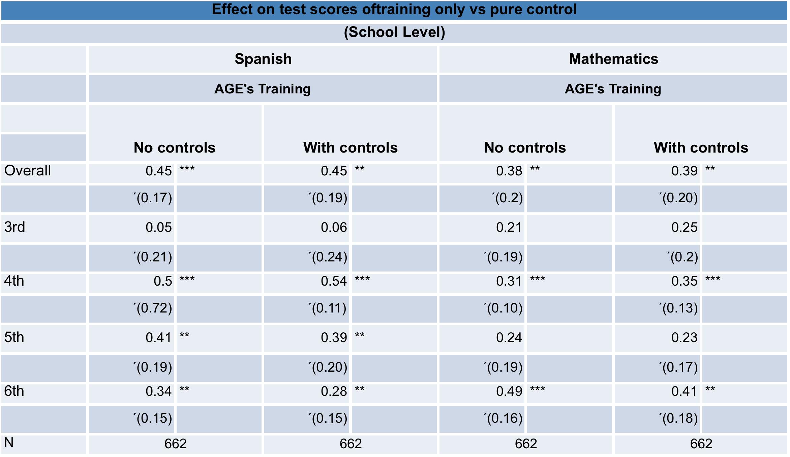
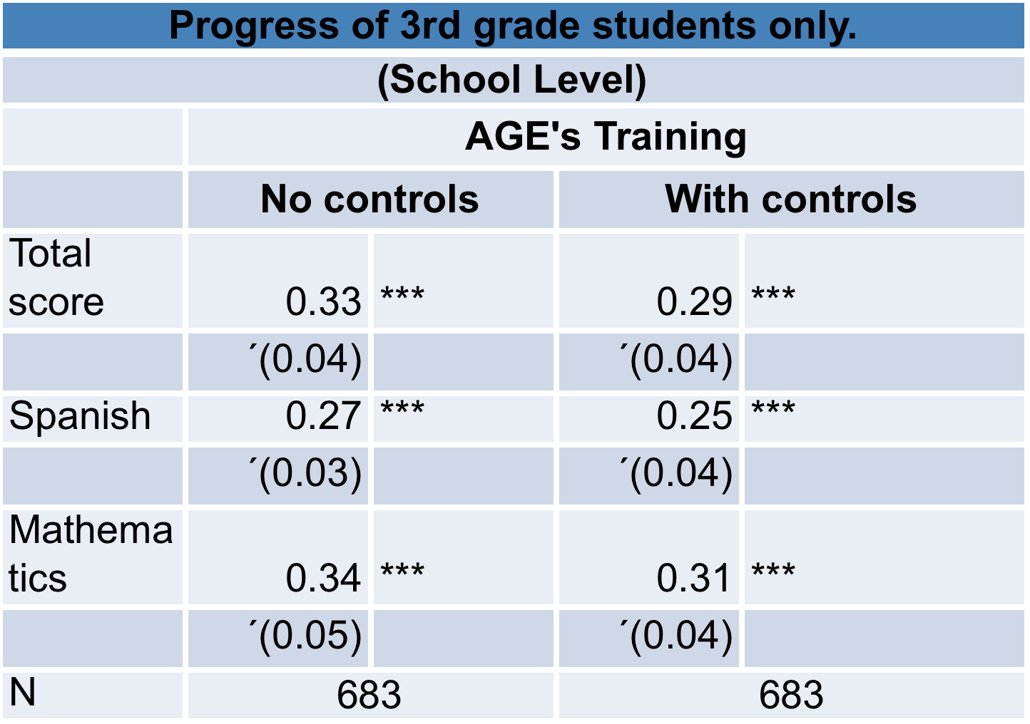

6. Conclusions
This experiment is trying to measure to what extent there is an impact on indicators of quality of education from a double amount of AGE, a School Based Management program that provides small amounts of cash to parent associations in order to make physical improvements in the schools. The project randomly selected 250 rural schools in Chiapas, Guerrero, Puebla and Yucatán, and also randomly assigned 125 to receive double amounts of AGE (treatment), and 125 to control (receive normal amounts of AGE). Surveys for teachers, directors, directors of parents associations, and students, are carried out for a baseline (2007) and follow ups (2008, 2009 and 2010).

This paper has presented some preliminary evidence of the possible impact of the program on quality of education indicators. We have calculated indicators from the 911 Census (repetition, failure and dropout rates) for 2007 to 2010, and also we have the ENLACE standardized test scores at the school level for 2007 to 2010. Using a Difference-in-Difference strategy we have found that there is some positive effects on indicators at the school level in increasing ENLACE test scores, especially for indigenous schools, and in repetition and failure for some grades. At the individual levels we look at the dynamic in terms of meeting, design of the workplan, attitudes and commitments towards improvements, but results only show an impact in reducing meeting for some of the agents.

Even though the mechanisms of participating through meeting with agents seems to be reduced, it may be that other mechanisms are playing to have the incidence on better test scores for some groups. More work is needed in determining if the effect comes from an incidence of changing within household activities for supervising children improvements in school and studying practices. In this sense, some studies, like Valdes et al (2009) have found for Mexico, using qualitative methods, that parents circumscribe their support for children improvements at school only within the household and not necessarily interacting with teachers and principals. However, according to teachers, who are more in contact with parents, they have increased they commitment and attitudes towards improvement, perhaps being this the mechanism increasing the outcomes.
Doubling cash grant to parents improves learning for young children more than 0.20 SD
Subsidy generates commitment and increased participation of parents
But training parents improves outcomes, even after 1 year implementation, at levels comparable to impact of doubling AGE grant
Parental empowerment a useful tool for generating interest in education in poor, rural, isolated communities

References
Caldwell, B.J. 2005. School-based Management. Education Policy Series. The International Institute for Educational Planning and The International Academy of Education. Paris and Brussels.

Di Gropello, E. 2006. “A Comparative Analysis of School-Based Management in Central America.” World Bank Working Paper No. 72. Washington D.C.

Di Gropello, E. and J.H. Marshall. 2005. “Teacher Effort and Schooling Outcomes in Rural Honduras,” in E. Vegas, ed., Incentives to Improve Teaching. Washington, D.C.: The World Bank.

Drury, D. and D. Levin. 1994. “School-based Management: The Changing Locus of Control in American Public Education.” Prepared for the Office of Educational Research Office of Research, US Department of Education, Washington D.C.

Excelsior. 2007. “Regresa violencia a Oaxaca y amenaza a la Guelagetza.” Tuesday, 11 July 2007 (www.nuevoexcelsior.com.mx).

Gertler, P., H.A. Patrinos and M. Rubio-Codina. 2006. “Empowering Parents to Improve Education: Evidence from Rural Mexico.” World Bank Policy Research Working Paper 3935.
Hall, G. and H.A. Patrinos (eds.). 2006. Indigenous Peoples, Poverty and Human Development in Latin America. London: Palgrave McMillan.
Hess, A. 1999. “Understanding Achievement (and Other) Changes under Chicago School Reform.” Educational Evaluation and Policy Analysis 21(1): 67-83.
Jimenez, E. and Y. Sawada. 2003. “Does community management help keep kids in schools? Evidence using panel data from El Salvador's EDUCO program.” CIRJE Discussion Paper.
Jimenez, E. and Y. Sawada. 1999. “Do Community-managed Schools Work? An Evaluation of El Salvador's EDUCO Program.” World Bank Economic Review. 13(3): 415-41.
Karim, S., C.A. Santizo Rodall and E.C. Mendoza. 2004. Transparency in Education. International Institute for Educational Planning and International Academy of Education. UNESCO, Paris and Brussels.

King, E.M. and B. Özler. 1998. “What’s Decentralization Got To Do With Learning? The Case of Nicaragua’s School Autonomy Reform.” Development Research Group, World Bank.

King, E.M., B. Özler and L.B. Rawlings. 1999. “Nicaragua’s School Autonomy Reform: Fact or Fiction?” World Bank Working Paper Series on Impact Evaluation of Education Reforms 19.

Leithwood, K. and T. Menzies. 1998. “Forms and Effects of School-Based Management: A Review.” Educational Policy 12(3): 325.

Lewis, M. 2006. “Decentralizing Education: Do Communities and Parents Matter?” Mimeo. Center for Global Development, Washington D.C.

Lopez-Calva, L. F. and L. D. Espinosa. 2006. “Efectos diferenciales de los programas compensatorios del CONAFE en el aprovechamiento escolar,” in Efectos del Impulso a la Participación de los Padres de Familia en la Escuela, CONAFE, México.

Manski, C.F. 1990. “Nonparametric Bounds on Treatment Effects.” American Economic Review 80(2): 319-323.

Murnane, R. J., J. B. Willet, and S. Cardenas. 2006. “Did Participation of Schools in Programa Escuelas de Calidad (PEC) Influence Student Outcomes?” Working Paper, Harvard University Graduate School of Education, Cambridge, MA.

Ozler, B. 2001. “Decentralization and Student Achievement: The case of Nicaragua’s School Autonomy Reform.” Working Paper on Impact Evaluation of Education Reforms. Washington, DC: World Bank.

Patrinos, H.A. 2006. “Mexico: AGEs (Apoyo a la Gestión Escolar) – School Management Support: A Qualitative Assessment.” World Bank. Processed.

Patrinos, H. and R. Kagia 2007. “Maximizing the Performance of Education Systems: The Case of Teacher Absenteeism” in J.E. Campos and S. Pradhan (eds.), The Many Faces of Corruption – Tracking Vulnerabilities at the Sector Level. World Bank, Washington D.C.

Ramirez, A. 2006. “Mexico,” in G. Hall and H.A. Patrinos, eds., Indigenous Peoples, Poverty and Human Development in Latin America. London: Palgrave McMillan

Santibañez, L. 2006. “School-Based Management Effects on Educational Outcomes: A Literature Review and Assessment of the Evidence Base.” World Bank.

Shapiro, J. and J. Moreno. 2006. “Compensatory education for disadvantaged Mexican students: an impact evaluation using propensity score matching.” World Bank.

Skoufias, E., and J. Shapiro. 2006. “The Pitfalls of Evaluating a School Grants Program Using Non-experimental Data.” World Bank Policy Research Working Paper No. 4036.

Valdes Cuervo, A., Martín Pavón, M. and Sanchez Escobedo, P. A. (2009). Participación d elos padres de alumnos de educación primaria en las actividades académicas de sus hijos. Revista Electrónica de Investigación Educativa, 11(1), available at http://redie.uabc.mx/vol11no1/contenido-valdes.html

World Bank. 2008a. What is School-Based Management. Washington DC: World Bank.

World Bank. 2008b. What do We Know about School-Based Management. Washington DC: World Bank.

