Paper Title
Name A. Lastname¹*, Name B. Lastname², and Name C. Lastname²
¹ Department, Faculty, University, City, Country
² Department, Faculty, University, City, Country
Email: first.author@hostname1.org; second.author@hostname2.org; third.author@hostname2.org
* Corresponding author

Abstract – The abstract must succinctly present the essential content of the manuscript in no more than 200 words. It should briefly describe the rationale and objectives of the study, the methods employed, the most relevant results, and the conclusions or implications arising from the research. The abstract should be understandable as a stand-alone text and should therefore avoid citations, references to tables or figures, web addresses, abbreviations that are not universally recognised, and any information that requires consultation of the full article.

Keywords – first required term, second required term, third required term, possible fourth term, possible fifth term

Introduction
The introduction should present the background and relevance of the research topic, situating the study within the existing literature. It should briefly outline the current state of knowledge, identify the main gaps or unresolved issues, and explain the contribution of the study in addressing them. The section should conclude by clearly stating the research objectives and, where appropriate, the research questions or hypotheses. Detailed discussions of previous studies should be reserved for the literature review section

Theoretical framework
This section should provide a critical overview of the literature relevant to the research topic, with the aim of contextualising the study and supporting its theoretical and empirical foundations. Authors should discuss the main findings, perspectives, and developments in the field, highlighting areas of consensus, debate, and limited evidence. The review should demonstrate how the existing literature informs the research questions and justifies the need for the present study. A clear and coherent organisation of the literature, whether thematic, methodological, or chronological, is strongly recommended

Methodology
This section should describe the research design, participants, data sources, instruments, and analytical procedures employed in the study. The methodological choices should be presented with sufficient clarity and detail to allow readers to understand how the research was conducted and to assess the validity and reliability of the findings. Where appropriate, information should be provided to support the replicability of the study

Results
This section should report the main findings of the study and discuss their significance in relation to the research objectives and the existing literature.

- Figures and tables (level 2 sub-section)
Figures and tables should be numbered consecutively, cited in the text (Fig. 1 or Table 1), and placed as close as possible to their first mention. Figure captions should appear below figures, while table titles should appear above tables. All labels and captions should be clear, concise, and informative.

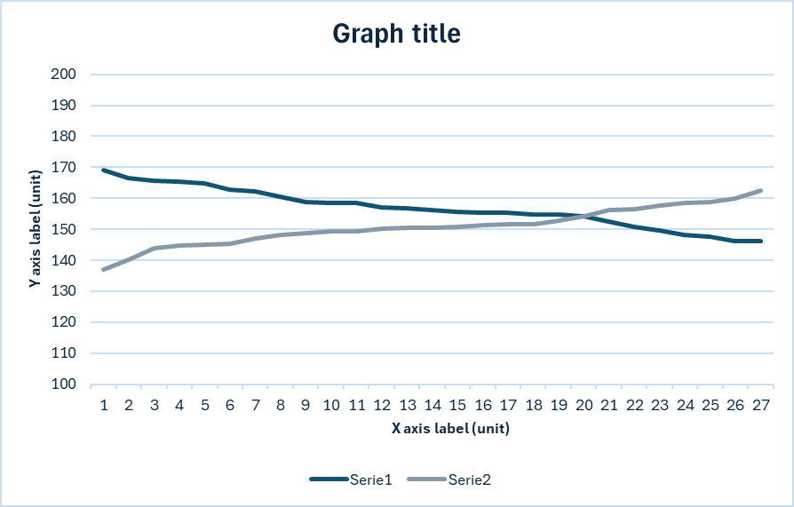
Fig. 1. Note how the caption is centred in the column.

If the manuscript contains images of any kind, these must be included in the manuscript and also uploaded separately in a single .zip file. The file should be named in accordance with the text and the images should be of a resolution suitable for printing (PNG or JPEG format, minimum 300 dpi). Tables and figures must be editable in all their components (i.e. they must not be provided as images, but rather in a format such as Excel).

Table 1. Type sizes for final papers
 | Appearance
 | Regular | Bold | Italic
6 | Table caption, table superscripts
8 | Section titles, tables, table names, first letters in table captions, figure captions, footnotes, text subscripts, and superscripts
9 | References, authors’ biographies | Abstract
10 | Authors’ affiliations, main text, equations, first letters in section titles |  | Subheading
11 | Authors’ names
14 | Paper title

- Figures and tables (level 2 subsection)
Here is the content of subsection (Level 2).

- Subsection (Level 3)
Here is the content of subsection (Level 3).

- Subsection (Level 4)
Here is the content of subsection (Level 4).

Numbered lists can be added as follows:
- First item;
- Second item;
- Third item.

Bulleted lists look like this:
- First bullet;
- Second bullet;
- Third bullet.

- References
References should be formatted consistently according to the citation style of the Journal and include all sources cited in the text. Authors are responsible for ensuring the accuracy and completeness of bibliographic information. For online sources, the URL and date of access should be provided where appropriate.
References must be numbered consecutively in brackets; for example, (Last name_1, Last name_2; year). In the reference list, the names of all authors must be included. If there are more than three authors, the abbreviation 'et al.' may be used.
Unpublished works, even if submitted to a journal, must be cited as 'unpublished', while works accepted but not yet available must be indicated as 'in press'.

- Footnotes
Footnotes must be numbered separately using superscripts (1, 2, …). The text of the footnote should be placed at the bottom of the column in which it is referenced, as shown in the example on the first page.

- Abbreviations and acronyms
Abbreviations and acronyms should always be written out in full the first time they appear in the text, even if they have already been defined in the abstract. It is preferable to avoid using them in the title, unless strictly necessary.

- Equations
Equations must be centred within the column. The paragraph containing them should have 6-point spacing before and after. Equations must be numbered consecutively, with the number placed in brackets and right-aligned, as in the example, 'Eq. (1). Latin symbols representing quantities and variables should be in italics, while Greek symbols should remain in normal type. When equations form part of a sentence, they must be accompanied by the appropriate punctuation, such as commas or full stops. For example: a + b = c (1).

Discussion
The conclusions should highlight the main findings of the study and their implications, linking them to the research objectives. This section may also discuss the limitations of the study and suggest directions for future research where appropriate.

Implications
This section should discuss the broader implications of the findings for research, policy, or practice, and outline potential directions for future studies.

Appendix
Any appendices must be identified by capital letters in alphabetical order (A, B, C, etc.). Within each appendix, elements such as figures and tables must be numbered using the same system. The letter corresponding to the appendix should be placed before the number. Designations such as 'Fig. A1', 'Table A1', and so on should be used to ensure proper organisation and ease of reference.

Conflict of Interest
Disclosure statement: ‘No potential conflict of interest was reported by the author(s).’

Author Contributions
Please clearly state the contribution of each author to the work. This can be a short paragraph summarising the specific tasks carried out by each contributor. For example: AB conducted the research, CD carried out the data analysis, and AB drafted the manuscript. All authors approved the final version of the work.

Funding
This research was funded by [Funding body], grant number [XXX]. / This research received no external funding.

Acknowledgment
The authors wish to thank A, B, C.

References
Book
Author, A. A. (Year). Title of the book. Publisher.
Example: Rossi, M. (2021). Research methodology. Laterza.

Edited book
Editor, A. A. (Ed.). (Year). Title of the book. Publisher.
Example: Bianchi, L. (Ed.). (2020). Educational research. Springer.

Book chapter
Author, A. A. (Year). Title of the chapter. In A. A. Editor (Ed.), Title of the book (pp. xx–xx). Publisher.
Example: Rossi, M. (2020). Evaluation models. In L. Bianchi (Ed.), Educational research (pp. 25–40). Springer.

Ebook
Author, A. A. (Year). Title of the book. Publisher. URL/DOI
Example: Rossi, M. (2021). Research methodology. Laterza. https://doi.org/xxxx

Journal article (with DOI)
Author, A. A. (Year). Title of the article. Title of the Journal, volume(issue), page range. https://doi.org/xxx
Example: Rossi, M. (2022). Quantitative methods. Journal of Psychology, 10(2), 45–60. https://doi.org/xxxx

Journal article (without DOI)
Author, A. A. (Year). Title of the article. Title of the Journal, volume(issue), page range.
Example: Rossi, M. (2022). Quantitative methods. Journal of Psychology, 10(2), 45–60.

Magazine article
Author, A. A. (Year, Month Day). Title of the article. Magazine Title, volume(issue), pages.
Example: Rossi, M. (2022, June 5). Education trends. Education Today, 12(2), 10–15.

Newspaper article
Author, A. A. (Year, Month Day). Title of the article. Newspaper Title. URL
Example: Rossi, M. (2022, June 5). Education reform. Corriere della Sera. https://...

Report (organization as author)
Organization Name. (Year). Title of the report. Publisher (if different). URL
Example: INVALSI. (2023). National evaluation report. https://...

Report (individual authors)
Author, A. A. (Year). Title of the report. Organization. URL
Example: Rossi, M. (2023). School performance report. INVALSI. https://...

Government document
Government Agency. (Year). Title of the document. URL
Example: Ministry of Education. (2022). Education policy report. https://...

Thesis / Dissertation (published)
Author, A. A. (Year). Title of the thesis (Doctoral dissertation/Master’s thesis). Institution. URL
Example: Rossi, M. (2021). Evaluation systems in education (Doctoral dissertation). University of Rome. https://...

Thesis / Dissertation (unpublished)
Author, A. A. (Year). Title of the thesis (Unpublished doctoral dissertation/master’s thesis). Institution.
Example: Rossi, M. (2021). Evaluation systems in education (Unpublished doctoral dissertation). University of Rome.

Conference paper (published)
Author, A. A. (Year). Title of the paper. In A. A. Editor (Ed.), Title of proceedings (pp. xx–xx). Publisher. DOI/URL
Example: Rossi, M. (2022). Assessment models. In L. Bianchi (Ed.), Proceedings of the Education Conference (pp. 12–20). Springer. https://doi.org/...

Conference presentation (unpublished)
Author, A. A. (Year, Month). Title of the presentation. Conference Name, Location.
Example: Rossi, M. (2022, May). Assessment models. Education Conference, Milan.

Webpage
Author, A. A. (Year, Month Day). Title of the page. Website Name. URL
Example: Rossi, M. (2023, May 12). How to cite in APA. EduBlog. https://...

Website
Author/Organization. (Year). Title of site. URL
Example: APA. (2023). APA Style. https://apastyle.apa.org

Blog post
Author, A. A. (Year, Month Day). Title of the post. Blog Name. URL
Example: Rossi, M. (2023, May 12). Citation rules. EduBlog. https://...

YouTube video
Author/Channel Name. (Year, Month Day). Title of the video [Video]. YouTube. URL
Example: APA Style. (2022, June 10). APA tutorial [Video]. YouTube. https://...

Additional Information
The complete manuscript (including references, appendices, tables, and abstract) must be between 4,000 and 7,000 words long.

